ACKNOWLEDGEMENT

In the accomplishment of this Database Connectivity(AISSCE: 2015) project successfully, many people have best owned upon me their blessings and the heart pledged support, this time I am utilizing to thank all the people who have been concerned with project. Primarily I would thank god for being able to complete this project with success. Then I would like to thank my principal **Mr. RAJESH KESHWANI SIR** and IP teacher **Mr. PUSHPRAJ SINGH SIR**, whose valuable guidance has been the ones that helped me patch this project and make it full proof success. His suggestions and his instructions have served as the major contributor towards the completion of the project. Then I would like to thank my parents and friends **TARUN GUPTA** & **SHIVAM MAHENDRA** who have helped me with their valuable suggestions and guidance has been helpful in various phases of the completion of the project. Last but not the least I would like to thank my classmates who have helped me a lot.

-----SAHAJ SINGH SACHDEVA

CASE STUDY

As We Know Voting condition of INDIA is NOW-A-DAYS is very poor and worse. Only 54% people come out of their home to vote. 30% people enjoy this day as public holiday. They enjoy this day with their family by organizing trips and picnic. Left 16% do not even came out of their house to caste vote. They think that no change will cause in the condition of Indian Government by their vote. They think that after every 5 years new government will form and rule on their country and make money for themselves. So for those people who enjoy this day as public holiday and think that voting is wastage of time, WE have DESIGNED an e-Application i.e. "Online Voting Machine" that can be installed on any P.C. or KIOSKS or any android Smartphone’s or Tablets. People can Vote by sitting at their home or anywhere using their mobile or pc......

This application will help in increase in "%" of voting. Also it aware the people, the time of voting. Also it saves the precious time of those people who came from their jobs to cast Vote.

Thanks!!!!!!

--DEVELOPERS

GENERAL INSTRUCTIONS

AND REQUIREMENTS

Minimum Resource Requirements:

1. JDK 1.5.0 or later version
2. MySQL Server 5.1 or later version
3. Intel PIV Processor or later
4. 256 MB RAM or more
5. At least 50 MB of Hard Disk space

For Optimum use of the Software Kindly Follow the following Steps or See the Readme File in CD Package.

* Copy the sahaj_bckp.sql file from package CD and paste it to your drive.
* Restoration of the MySQL database of the application is required.
* For this open Command Prompt from Start Button or by pressing WINDOWS+R key and type cmd.

Enter cmd in Run Window

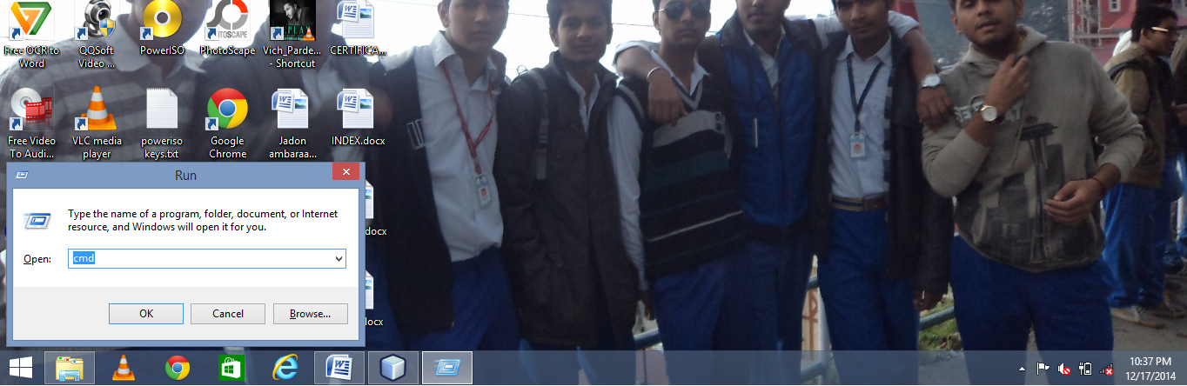

* Type CD <space> <MySQL bin Directory>. Hit Enter.
* Now type the following command:

Mysql –u root –p ovs < “path of the MySQL backup file”>

And press Enter.

1. A password will be seeked for. Enter your MySQL Server Password and press Enter.
2. The Database Backup is now restored to your PC.

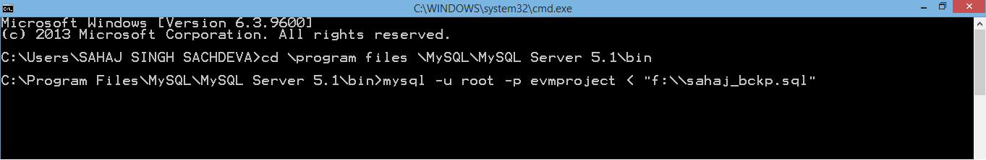

1. Now move to the software package CD and open “evmproject” folder in it. Now open the appcontent folder and double click on “evm.exe” executable jar file to run the application.

* Note: Please remember to change your MySql root password to “RRMPS” (IN CAPS LETTER ONLY) to avoid connectivity errors.

**Database**

**Structures**

MySQL MAIN SCREEN

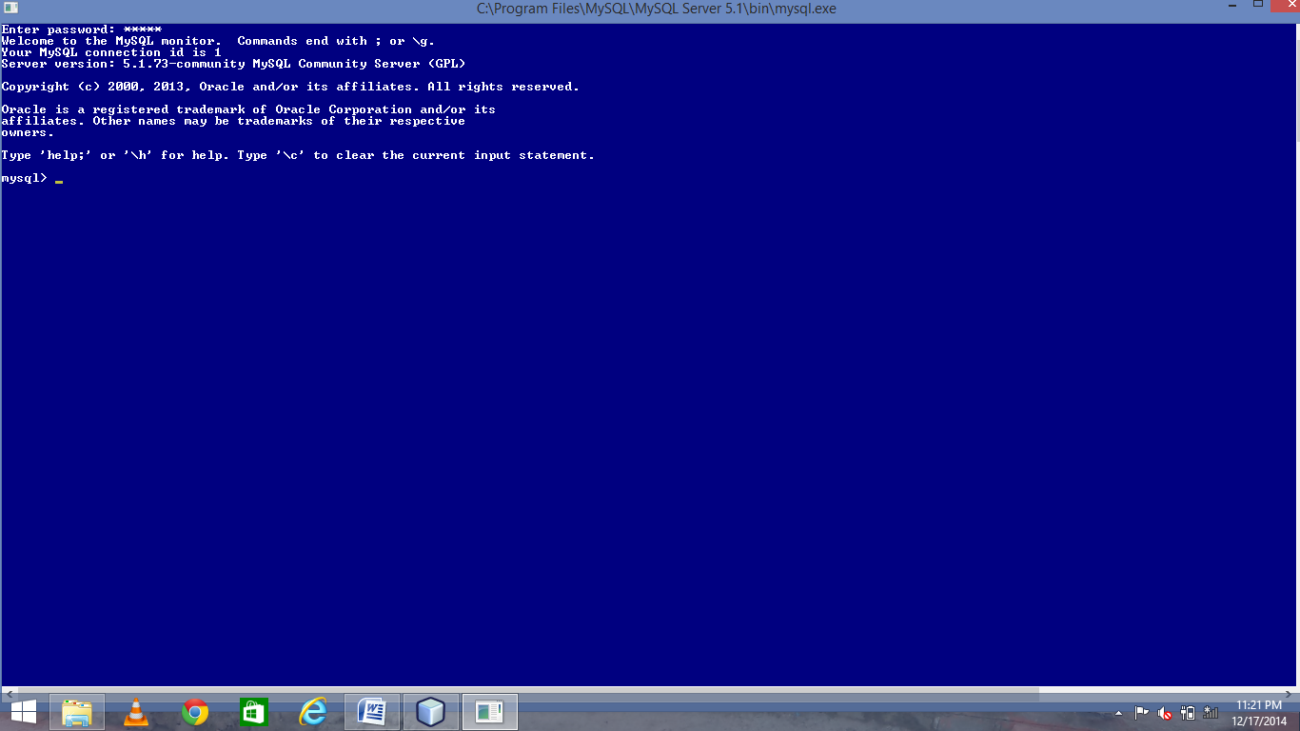

TABLES OF DATABASE OVS

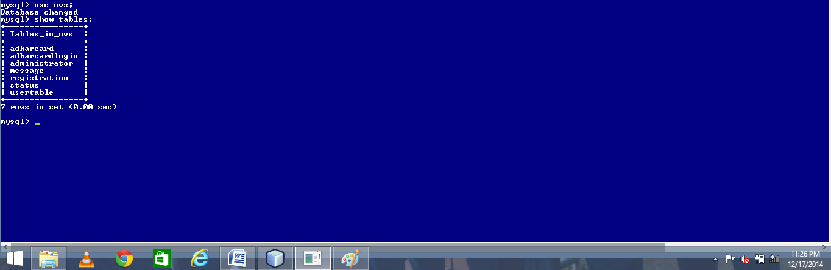

Table: Adharcard

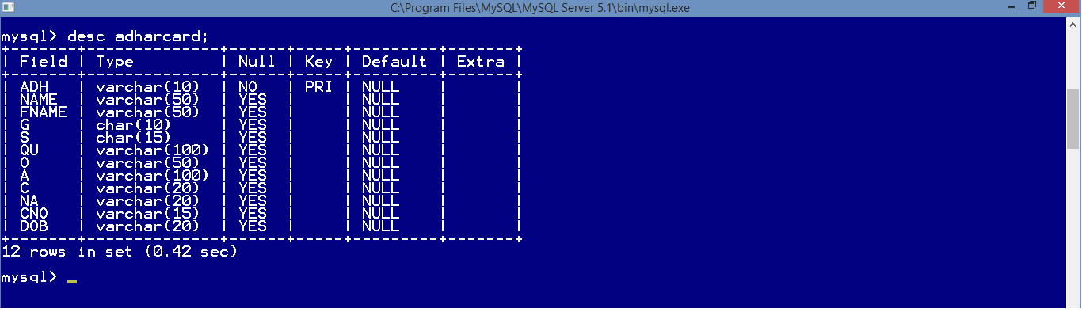

Table: Adharcardlogin

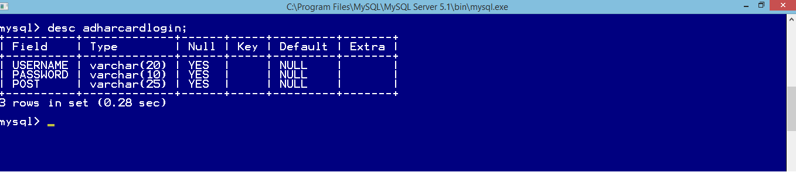

Table: Administrator

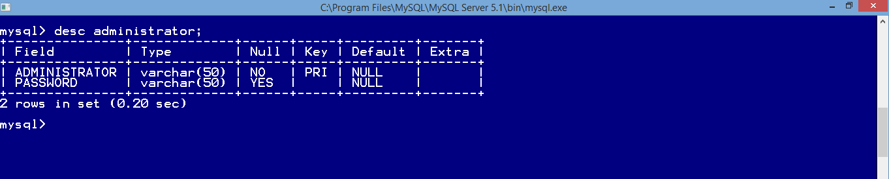

Table: Message

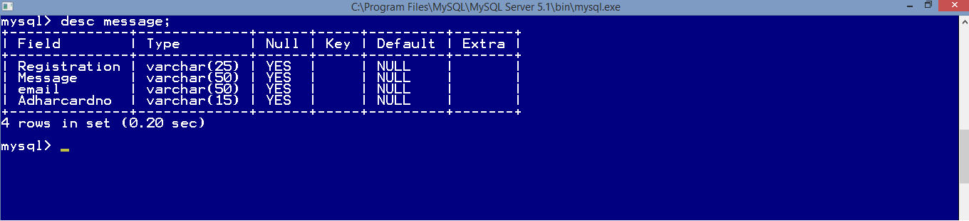

Table: Registration

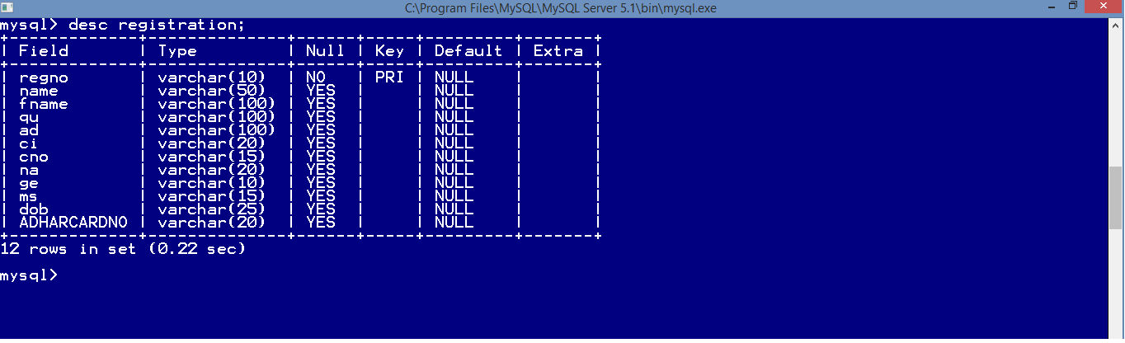

Table: Status

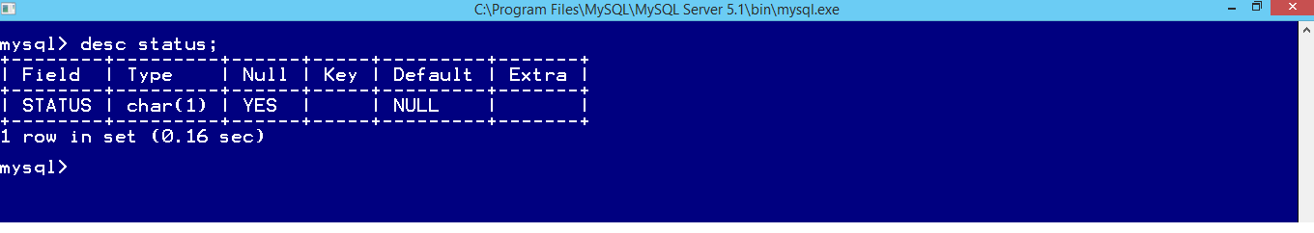

Table: Usertable

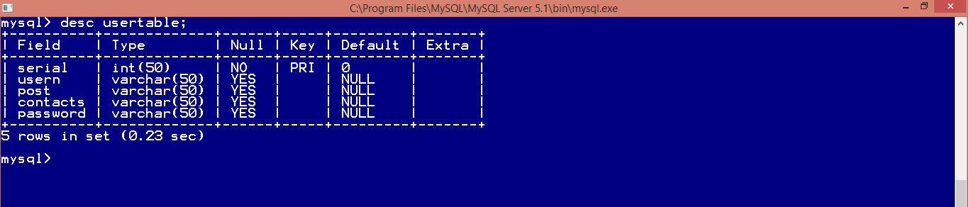

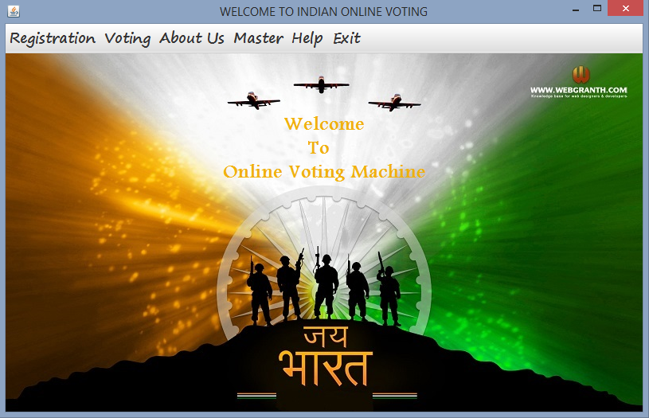Main Screen

Source Code:

public class homepage extends javax.swing.JFrame {

/** Creates new form homepage */

public homepage() {

initComponents();

}

public javax.swing.JMenuItem sf()

{

return j ;

}

private void jMenuItem1ActionPerformed(java.awt.event.ActionEvent evt) {

int i=JOptionPane.showConfirmDialog(this,"Do you Want To Exit");

if(i==0)

{this.dispose();}

// for exiting application through menu item

}

private void nrActionPerformed(java.awt.event.ActionEvent evt) {

new NEWREGISTRATION().setVisible(true);

// to open registration form

}

private void jMenuItem2ActionPerformed(java.awt.event.ActionEvent evt) {

new Password().setVisible(true);

// to open create/update adharcard menu item**}**

private void jMenuItem10ActionPerformed(java.awt.event.ActionEvent evt) {

new checkregistration().setVisible(true);

// to open check registration form

}

private void jMenuItem3ActionPerformed(java.awt.event.ActionEvent evt) {

new password1().setVisible(true);

// to open administrator menu item

}

private void jMenuItem6ActionPerformed(java.awt.event.ActionEvent evt) {

new any_Query().setVisible(true);

// to open any query menu item

}

private void jMenuItem4ActionPerformed(java.awt.event.ActionEvent evt) {

new about_us().setVisible(true);

// to open about us menu item

}

private void formWindowClosing(java.awt.event.WindowEvent evt) {

int i=JOptionPane.showConfirmDialog(this,"Do you Want To Exit");

if(i==0)

{System.exit(0);}

// to exit through exit button

}

private void jMenuItem5ActionPerformed(java.awt.event.ActionEvent evt) {

new developers().setVisible(true);

// to open developers menu item

}

private void jMenu1ActionPerformed(java.awt.event.ActionEvent evt) {

new checkregistration().setVisible(true);

// to open check registration menu item

}

private void CVActionPerformed(java.awt.event.ActionEvent evt) {

new VoteLogin().setVisible(true);

// to open cast vote menu item

**}**

private void formWindowOpened(java.awt.event.WindowEvent evt) {

try

{Class.forName("java.sql.DriverManager");

Connection C=(Connection)DriverManager.getConnection("jdbc:mysql://localhost:3306/OVS","root","RRMPS");

Statement S=(Statement)C.createStatement();

String query="select * from status;";

ResultSet r =S.executeQuery(query);

r.last();

String st=r.getString("status");

if(st.equals("0")){

j.setEnabled(false);

}

}

catch(Exception e){

JOptionPane.showMessageDialog(this,e.getMessage());

}

// to check status of voting

**How to use this application??**

Creation of Adhar Card

Step1:- Asking to create Adhar Card

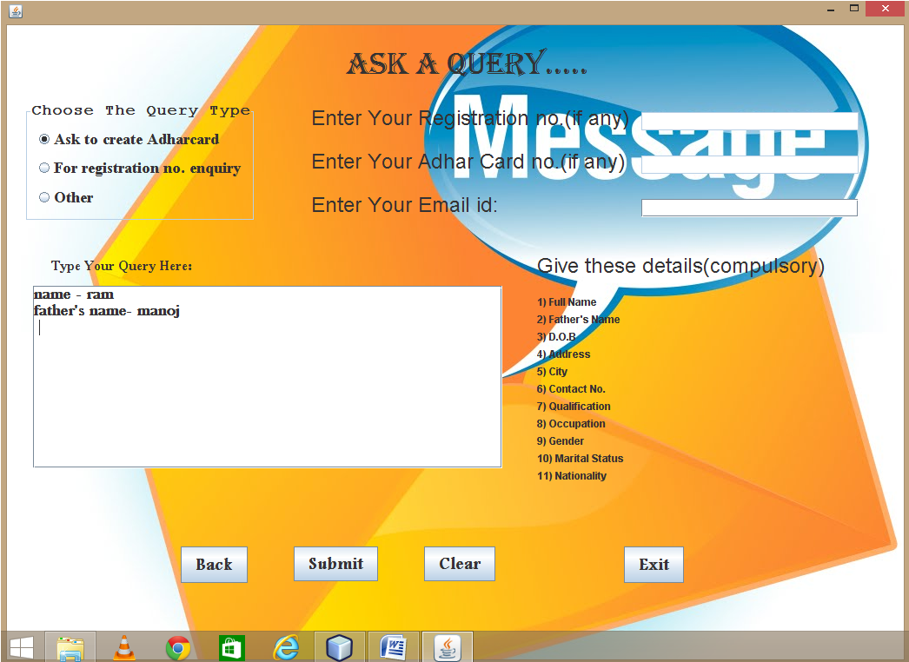

1. First the user will ask to make Adhar Card..
2. He had to go to Help Menu.
3. Then click on Any Query.
4. Click on Ask to Create Adhar Card. And enter all the following details.

Step2:Create/Update Adhar Card

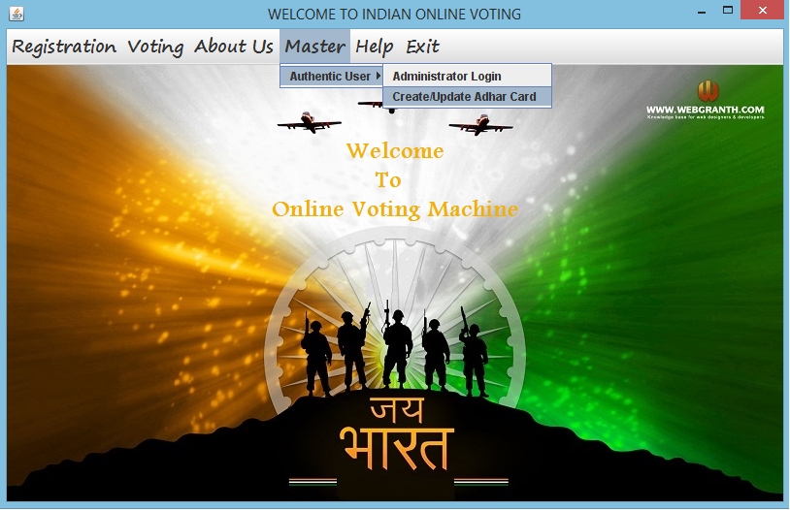

1. First the authentic user will move to Master Menu.
2. Click on Create/Update Adhar Card.
3. Than a password will be asked to the authentic user.
4. Authentic user will enter the password.

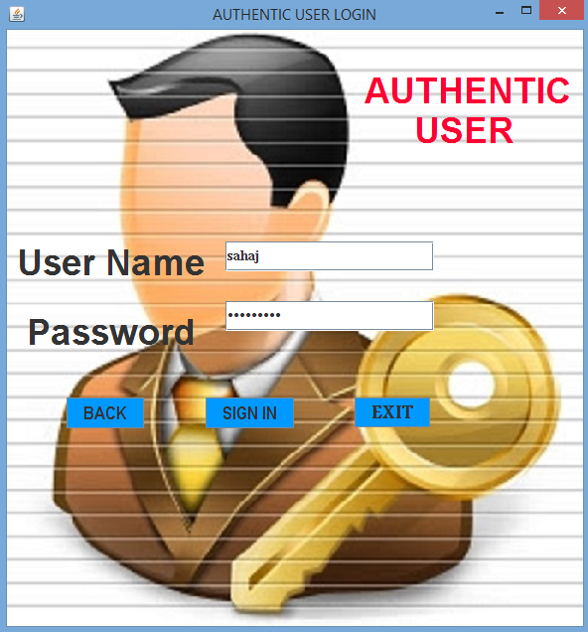

Source Code for Password frame:

import java.sql.Connection;

import java.sql.Statement;

import java.sql.ResultSet;

import java.sql.DriverManager;

import javax.swing.JOptionPane;

public class Password extends javax.swing.JFrame {

public Password() {

initComponents();

}

Button SIGN IN:

private void jButton1ActionPerformed(java.awt.event.ActionEvent evt) {

String us=(String)t1.getText(); //getting user name

String ps=t2.getText(); //getting password

{ try

//Starting of try

{

Class.forName("java.sql.DriverManager");

Connection C = (Connection)DriverManager.getConnection("jdbc:mysql:/ /localhost:3306/ovs","root","RRMPS");

Statement S=(Statement)C.createStatement();

String query="select * from USERTABLE where usern='"+us+"';";

ResultSet r =S.executeQuery(query);

r.next();

String pwd=r.getString("password");

String user=r.getString("usERN");

String post=r.getString("post");

if (us.equalsIgnoreCase(user)) //comparing application username with database username

{

if(ps.equals(pwd))

//user name is correct now comparing application password with database password

{

if(post.equalsIgnoreCase("Create adhar card"))

//username and password is correct now comparing application post with database post

{this.setVisible(false);

new ADHARCARDFORM1().setVisible(true);

}

else if(post.equalsIgnoreCase("Update adhar card"))

//username and password is correct now comparing application post with database post

{this.setVisible(false);

new UPDATEADHARCARD().setVisible(true);

}

}

else

JOptionPane.showMessageDialog(null,"INCORRECT USERNAME or PASSWORD or is CASE SENSITIVE");

}

}//ending of try

catch(Exception e)

{

JOptionPane.showMessageDialog(null,"INCORRECT USERNAME or PASSWORD or is CASE SENSITIVE");

} }

Button BACK:

this.setVisible(false);

new homepage().setVisible(true);

Button EXIT:

System.exit(0);

1. If the user is of creating Adhar Card than Adhar Card form will be opened.

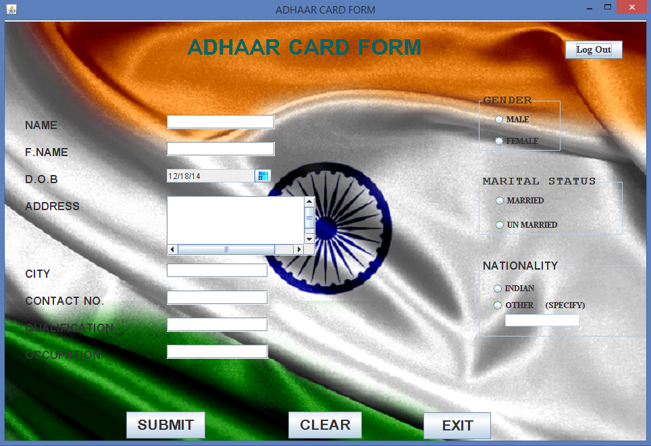

Source Code for Adhar Card frame:

import java.sql.Connection;

import java.sql.Statement;

import java.sql.ResultSet;

import java.sql.DriverManager;

import java.util.Calendar;

import javax.swing.JOptionPane;

Button SUBMIT:

private void jButton1ActionPerformed(java.awt.event.ActionEvent evt) {

Calendar D=d1.getSelectedDate();//getting date

String dob=D.get(D.DATE)+"-"+(D.get(D.MONTH)+1)+"-"+D.get(D.YEAR);

int y=D.get(D.YEAR);

if(y<=2014)

//Comparing year so that user enter not more than current year

{

String Name=n.getText(); //getting name

String fname=fn.getText(); //getting father's name

String g=null;

String s=null;

long adh;

String na=null;

if (ma.isSelected()==true) {

g="Male";

} //for radio button male

else if(fem.isSelected() == true) {

g="Female";

} //for radio button female

if (m1.isSelected()==true) {

s="Married";

} //for radio button married

else if(m2.isSelected() == true) {

s="Unmarried";

} //for radio button unmarried

String qu=q.getText(); //getting qualification

String o=oc.getText(); //getting occupation

String a=ad.getText(); //getting address

String c=ci.getText(); //getting city

if (in.isSelected()==true)

{

na="Indian";

}

else if (ots.isSelected()==true)

{

na=ot.getText();

}

String cno=cn.getText(); //getting contact no.

int lcn=cno.length();

if (n.getText().equals("")) //checking name field whether it is empty or not

{

JOptionPane.showMessageDialog(this,"Please fill Name.....");

}

else if (fn.getText().equals("")) //checking fathers name field whether it is empty or not

{

JOptionPane.showMessageDialog(this,"Please fill Father's Name.....");

}

else if (q.getText().equals("")) //checking qualification field whether it is empty or not

{

JOptionPane.showMessageDialog(this,"Please fill Qualification......");

}

else if (oc.getText().equals("")) //checking occupation field whether it is empty or not

{

JOptionPane.showMessageDialog(this,"Please fill Occupation......");

}

else if (ad.getText().equals("")) //checking address field whether it is empty or not

{

JOptionPane.showMessageDialog(this,"Please fill Addresss.....");

}

else if (ci.getText().equals("")) //checking city field whether it is empty or not

{

JOptionPane.showMessageDialog(this,"Please fill City Name.....");

}

else if (cn.getText().equals("")) //checking contact field whether it is empty or not

{

JOptionPane.showMessageDialog(this,"Please fill Contact no.....");

}

else if (lcn>10 || lcn<=9)

//checking whether mobile field should not have less than or more than 10 values

{

JOptionPane.showMessageDialog(this,"Please fill valid Contact no.....");

}

else if (ma.isSelected()==false && fem.isSelected()==false)

//checking gender field whether it is empty or not

{

JOptionPane.showMessageDialog(this,"Please Select Gender.....");

}

else if (m1.isSelected()==false && m2.isSelected()==false)

//checking marital status field whether it is empty or not

{

JOptionPane.showMessageDialog(this,"Please Select Marital Status.....");

}

else if ((in.isSelected()==false && ots.isSelected()==false )||(ots.isSelected()==true && ot.getText().equals("")))

//checking nationality field whether it is empty or not

{

JOptionPane.showMessageDialog(this,"Please Specify Nationality.....");

}

else { try

{

Class.forName("java.sql.DriverManager");

Connection C=(Connection)DriverManager.getConnection("jdbc:mysql://localhost:3306/OVS","root","RRMPS");

Statement S=(Statement)C.createStatement();

String query="select max(adh) from ADHARCARD;";

ResultSet r =S.executeQuery(query);

r.next();

long acc=Long.parseLong(r.getString("max(adh)"));

adh=acc+1;

String A="Insert Into ADHARCARD values('"+adh+"','"+Name+"','"+fname+"','"+g+"','"+s+"','"+qu+"','"+o+"','"+a+"','"+c+"','"+na+"','"+cno+"','"+dob+"');";

S.executeUpdate(A);

JOptionPane.showMessageDialog(null,"Adhar Card Created!!!!"+ "\n adhar card no. is "+adh);

}

catch(Exception e)

{

JOptionPane.showMessageDialog(this,e.getMessage());

}

} //end of else

} //end of first if

else {

JOptionPane.showMessageDialog(this,"Please specify the correct year");}

Button CLEAR:

private void jButton2ActionPerformed(java.awt.event.ActionEvent evt) {

d1.setSelectedDate(null); //clearing date

buttonGroup1.clearSelection(); //clearing buttongroup1

buttonGroup2.clearSelection(); //clearing buttongroup2

buttonGroup3.clearSelection(); //clearing buttongroup3

n.setText(""); //clearing name field

fn.setText(""); //clearing father's name field

q.setText(""); //clearing qualification field

oc.setText(""); //clearing occupation field

ad.setText(""); //clearing address field

ci.setText(""); //clearing city field

cn.setText(""); //clearing contact no field

ot.setText(""); //clearing others field

ot.setEnabled(false); //disabling others field

}

Button EXIT:

System.exit(0);

Button LOG OUT:

this.setVisible(false);

new Password().setVisible(true);

1. If the user is of updating Adhar Card than Update Adhar Card form will be open.

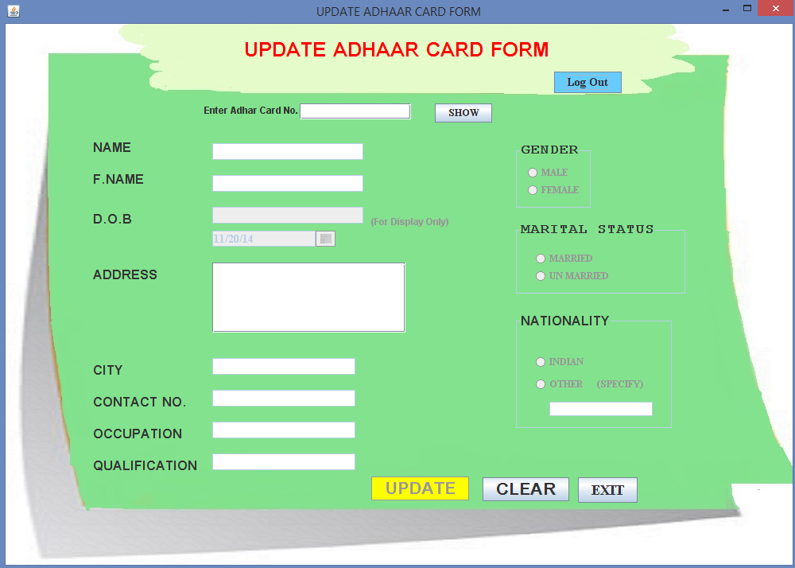

Source Code for Update Adhar Card frame:

Button SHOW:

private void jButton1ActionPerformed(java.awt.event.ActionEvent evt) {

dy.setSelectedDate(null); //To value of Calendar to null

buttonGroup1.clearSelection(); //To clear buttongroup1

buttonGroup2.clearSelection(); //To clear buttongroup2

buttonGroup3.clearSelection(); //To clear buttongroup3

Object q=T1.getText(); //To accept adharcardno

{

//starting of try

try

{

Class.forName("java.sql.DriverManager");

Connection C=(Connection)DriverManager.getConnection("jdbc:mysql://localhost:3306/OVS","root","RRMPS");

Statement S=(Statement)C.createStatement();

String query="select * from ADHARCARD WHERE ADH='"+q+"';";

ResultSet r =S.executeQuery(query);

if (r.first()==false) //if adhar card no. is wrong

{

JOptionPane.showMessageDialog(this,"Enter correct Adhar Card No.....");

B1.setEnabled(false); //to make register button disable

T1.setEnabled(true); //to make enter adhar textfield disable

n.setEnabled(false); //to make nsme textfield disable

fn.setEnabled(false); //to make father's name textfield disable

qua.setEnabled(false); //to make qualification textfield disable

dy.setEnabled(false); //to make datechooser disable

oc.setEnabled(false); //to make occupation textfield disable

ad.setEnabled(false); //to make address textfield disable

ci.setEnabled(false); //to make city textfield disable

cn.setEnabled(false); //to make contact no textfield disable

ma.setEnabled(false); //to make male radiobutton disable

fem.setEnabled(false); //to make female radiobutton disable

in.setEnabled(false); //to make india radiobutton disable

ots.setEnabled(false); //to make other radiobutton disable

ot.setEnabled(false); //to make other textfield disable

m1.setEnabled(false); //to make married radiobutton disable

m2.setEnabled(false); //to make unmarried radiobutton disable

}

else

{

{

String ni=r.getString("name"); //to get name from database

String mi=r.getString("fname"); //to get father's name from database

String o=r.getString("qu"); //to get qualification from database

String p=r.getString("a"); //to get address from database

String w=r.getString("c"); //to get city from database

String yi=r.getString("cno"); //to get contact no from database

String u=r.getString("g"); //to get gender from databse

String v=r.getString("s"); //to get marital status from database

String na=r.getString("NA"); //to get nationality from database

String occu=r.getString("O"); //to get occupation from database

String DOB1=r.getString("DOB"); //to get dob from database

n.setText(ni); //to set name

fn.setText(mi); //to set father's name

qua.setText(o); //to set qualification

oc.setText(occu); //to set occupation

ad.setText(p); //to set address

ci.setText(w); //to set city

k.setText(DOB1); //to set dob in textfield

cn.setText(yi); //to set contact no.

if(u.equalsIgnoreCase("male"))

{ ma.setSelected(true); //to set male }

else if(u.equalsIgnoreCase("female"))

{ fem.setSelected(true); //to set female }

if(v.equalsIgnoreCase("married"))

{ m1.setSelected(true); //to set married }

else if(v.equalsIgnoreCase("unmarried"))

{ m2.setSelected(true); //to set unmarried }

if(na.equalsIgnoreCase("Indian"))

{ in.setSelected(true); //to set Indian }

else

{ ot.setEnabled(true); //to enable other textfield

ots.setSelected(true); //to set other

ot.setText(na); //to set other nationality }

k.setEnabled(true); //to enable date textfield

n.setEnabled(true); //to enable name textfield

fn.setEnabled(true); //to enable father's name textfield

qua.setEnabled(true); //to enable qualification textfield

dy.setEnabled(true); //to enable dob combo

oc.setEnabled(true); //to enable occupation textfield

ad.setEnabled(true); //to enable address textfield

ci.setEnabled(true); //to enable city textfield

cn.setEnabled(true); //to enable contact no textfield

ma.setEnabled(true); //to enable male radiobutton

fem.setEnabled(true); //to enable female radiobutton

in.setEnabled(true); //to enable indian radiobutton

ots.setEnabled(true); //to enable other radiobutton

m1.setEnabled(true); //to enable married radiobutton

m2.setEnabled(true); //to enable unmarried radiobutton

B1.setEnabled(true); //to enable register button } //end of loop

} //end of else

}

catch(Exception e)

{

} } }

Button UPDATE:

private void B1ActionPerformed(java.awt.event.ActionEvent evt) {

Object q12=T1.getText(); //getting adharcard no

Object q1=n.getText(); //getting name

Object q2=fn.getText(); //getting father's name

Calendar D=dy.getSelectedDate(); //getting date

Object q4=qua.getText(); //getting qualification

Object q5=oc.getText(); //getting occupation

Object q8=ad.getText(); //getting address

Object q6=ci.getText(); //getting city

Object q7=cn.getText(); //getting contact no.

String g=null;

String s=null;

long adh;

String na=null;

if (ma.isSelected()==true)

{ g="Male"; //getting male }

else if(fem.isSelected() == true)

{ g="Female"; //getting female }

if (m1.isSelected()==true)

{ s="Married"; //getting status as married }

else if(m2.isSelected() == true)

{ s="Unmarried"; //getting status as unmarried }

if (in.isSelected()==true)

{ na="Indian"; //getting nationality as Indian }

else if (ots.isSelected()==true)

{ na=ot.getText(); //getting other nationality }

String cno=cn.getText(); //getting contact no

if (n.getText().equals(""))

{ JOptionPane.showMessageDialog(this,"Please fill Name....."); }

else if (fn.getText().equals(""))

{ JOptionPane.showMessageDialog(this,"Please fill Father's Name....."); }

else if (qua.getText().equals(""))

{ JOptionPane.showMessageDialog(this,"Please fill Qualification......"); }

else if (oc.getText().equals(""))

{ JOptionPane.showMessageDialog(this,"Please fill Occupation......"); }

else if (ad.getText().equals(""))

{ JOptionPane.showMessageDialog(this,"Please fill Addresss....."); }

else if (ci.getText().equals(""))

{ JOptionPane.showMessageDialog(this,"Please fill City Name....."); }

else if (cn.getText().equals(""))

{ JOptionPane.showMessageDialog(this,"Please fill Contact no....."); }

else if (ma.isSelected()==false && fem.isSelected()==false)

{ JOptionPane.showMessageDialog(this,"Please Select Gender....."); }

else if (m1.isSelected()==false && m2.isSelected()==false)

{ JOptionPane.showMessageDialog(this,"Please Select Marital Status....."); }

else if ((in.isSelected()==false && ots.isSelected()==false )||(ots.isSelected()==true && ot.getText().equals("")))

{ JOptionPane.showMessageDialog(this,"Please Specify Nationality....."); }

else if(D==null)

{ JOptionPane.showMessageDialog(this,"Please enter your Date of Birth again for Reconfirmation"); }

else { String dob=D.get(D.DATE)+"-"+(D.get(D.MONTH)+1)+"-"+D.get(D.YEAR);

//starting of try

try {

Class.forName("java.sql.DriverManager");

Connection C=(Connection)DriverManager.getConnection("jdbc:mysql://localhost:3306/OVS","root","RRMPS");

Statement S=(Statement)C.createStatement();

String query="update adharcard set NAME='"+q1+"',FNAME='"+q2+"',G='"+g+"',S='"+s+"',QU='"+q4+"',O='"+q5+"',A='"+q8+"',C='"+q6+"',NA='"+na+"',CNO='"+q7+"',DOB='"+dob+"' Where ADH='"+q12+"';";

S.executeUpdate(query);

JOptionPane.showMessageDialog(null,"UPDATION SUCCESSFULL.....!!!!");

}//ending of try

catch(Exception e)

{ JOptionPane.showMessageDialog(this,e.getMessage()); }

T1.setEnabled(false); //disabling adharcard textfield

n.setEnabled(false); //disabling name textfield

fn.setEnabled(false); //disabling father's name textfield

qua.setEnabled(false); //disabling qualification textfield

dy.setEnabled(false); //disabling date combo

oc.setEnabled(false); //disabling occupation textfield

ad.setEnabled(false); //disabling address textfield

ci.setEnabled(false); //disabling city textfield

cn.setEnabled(false); //disabling contact no textfeld

ma.setEnabled(false); //disabling male radiobutton

fem.setEnabled(false); //disabling female radiobutton

in.setEnabled(false); //disabling indian radiobutton

ots.setEnabled(false); //disabling other radiobutton

ot.setEnabled(false); //disabling other textfield

m1.setEnabled(false); //disabling married radiobutton

m2.setEnabled(false); //disabling unmarried radiobutton

} }

Button CLEAR:

private void jButton2ActionPerformed(java.awt.event.ActionEvent evt) {

k.setText(""); //to clear date textfield

T1.setText(""); //to clear adharcard textfield

n.setEnabled(false); //to diable name textfield

fn.setEnabled(false); //to diable father's name textfield

qua.setEnabled(false); //to diable qualification textfield

dy.setEnabled(false); //to diable date textfield

oc.setEnabled(false); //to diable occupation

ad.setEnabled(false); //to diable address textfield

T1.setEnabled(true); //to enable adharcardno textfield

ci.setEnabled(false); //to diable city textfield

cn.setEnabled(false); //to diable contact no. textfield

ma.setEnabled(false); //to diable male radiobutton

fem.setEnabled(false); //to diable female radiobutton

in.setEnabled(false); //to diable indian radiobutton

ots.setEnabled(false); //to diable other radiobutton

ot.setEnabled(false); //to diable other textfield

m1.setEnabled(false); //to diable married radiobutton

m2.setEnabled(false); //to diable unmarried radiobutton

dy.setSelectedDate(null); //to set dob combo value null

buttonGroup1.clearSelection(); //to clear buutongroup1

buttonGroup2.clearSelection(); //to clear buutongroup2

buttonGroup3.clearSelection(); //to clear buutongroup3

n.setText(""); //to clear name textfield

fn.setText(""); //to clear father's name textfield

qua.setText(""); //to clear qualification textfield

oc.setText(""); //to clear occupation textfield

ad.setText(""); //to clear address textfield

ci.setText(""); //to clear city textfield

cn.setText(""); //to clear contact no. textfield

ot.setText(""); //to clear other textfield

ot.setEnabled(false); //to disable other textfield

B1.setEnabled(false); //to diable register button

Button EXIT:

private void jButton3ActionPerformed(java.awt.event.ActionEvent evt) {

this.setVisible(false);

new homepage().setVisible(true);

Button LOG OUT:

private void jButton4ActionPerformed(java.awt.event.ActionEvent evt) {

this.setVisible(false);

new Password().setVisible(true);

1. If the password is incorrect. Than error will be occurred.

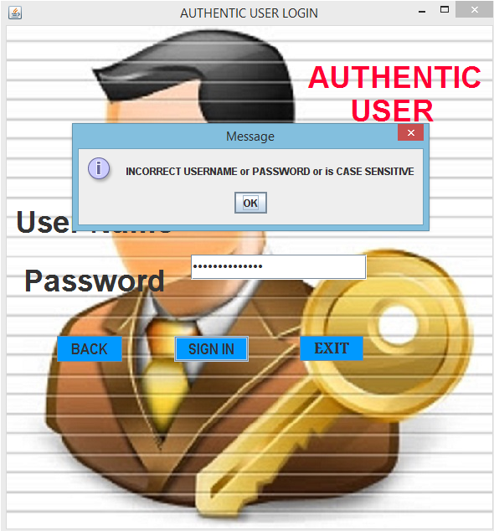

Step 2: Registration for Voting

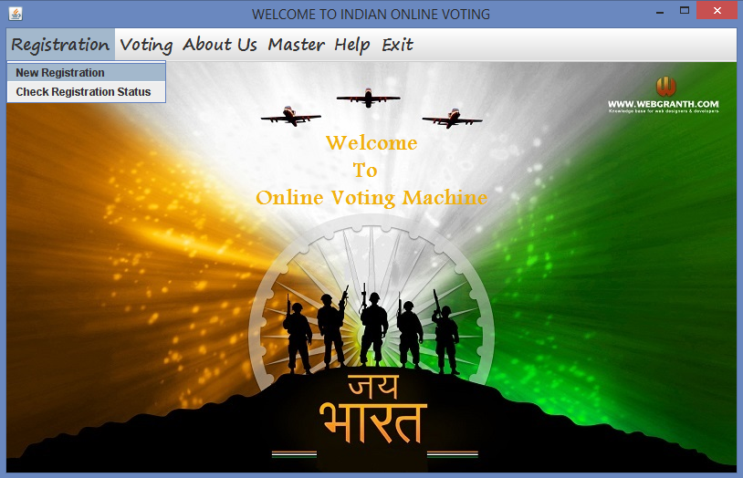

1. Click on Registration Menu.
2. Move to New Registration.
3. New Registration form will be open.

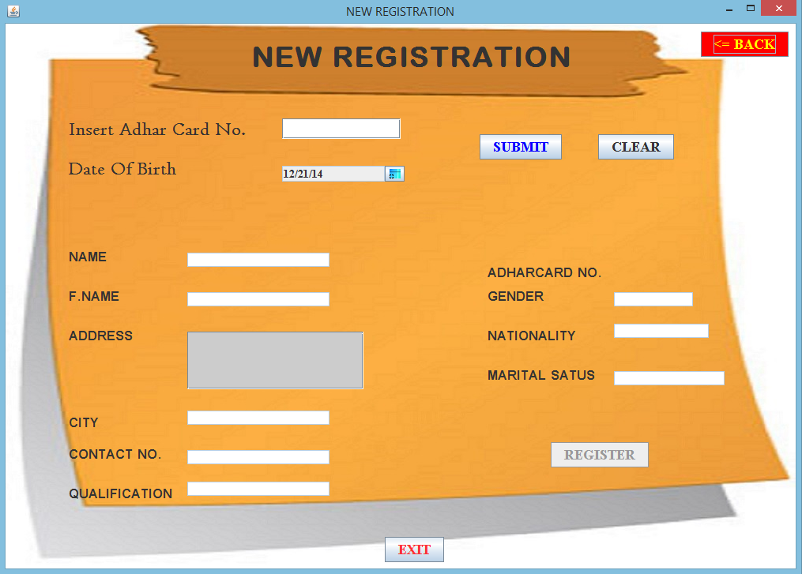

Button SUBMIT:

private void but1ActionPerformed(java.awt.event.ActionEvent evt) {

String ad;

ad=t1.getText();//getting adhar card no

Calendar D=d1.getSelectedDate();

String dob=D.get(D.DATE)+"-"+(D.get(D.MONTH)+1)+"-"+D.get(D.YEAR);//getting date

//starting of try

{ try

{

Class.forName("java.sql.DriverManager");

Connection C=(Connection)DriverManager.getConnection("jdbc:mysql://localhost:3306/ovs","root","RRMPS");

Statement S=(Statement)C.createStatement();

String query="select * from ADHARCARD WHERE ADH='"+ad+"' and DOB='"+dob+"';";

ResultSet r =S.executeQuery(query);

if(r.first()==false) //if details are not found

{

JOptionPane.showMessageDialog(this,"Details Not Found...Specify Correct Details");

}

else

{

{

String ni=r.getString("name"); //getting name from database

String mi=r.getString("fname"); //getting father's name from database

String o=r.getString("qu"); //getting qualification from database

String p=r.getString("a"); //getting address from database

String w=r.getString("c"); //getting city from database

String yi=r.getString("cno"); //getting contact no from database

String u=r.getString("g"); //getting gender from database

String v=r.getString("s"); //getting marital status from database

String na=r.getString("NA"); //getting nationality from database

String date=r.getString("DOB"); //getting dob from database

n.setText(ni); //setting name in textfield

f.setText(mi); //setting father's name in textfield

q.setText(o); //setting qualification in textfield

a.setText(p); //setting address in textfield

c.setText(w); //setting city in textfield

co.setText(yi); //setting contact no in textfield

na1.setText(na); //setting nationality in textfield

but.setEnabled(true); //enabling register button

L1.setText(ad); //setting adhar card

t2.setText(u); //setting gender in textfeld

t3.setText(v); //setting marital status

}

}

} //ending of try

catch(Exception e)

{

}

}

}

Button REGISTER:

private void butActionPerformed(java.awt.event.ActionEvent evt) {

int b=Integer.parseInt(t1.getText());//getting adharcard

Calendar ef=d1.getSelectedDate();//getting date

String dob1=ef.get(ef.DATE)+"-"+(ef.get(ef.MONTH)+1)+"-"+ef.get(ef.YEAR);

int y=ef.get(ef.YEAR);

if(y<=1997)

{

{try

{

Class.forName("java.sql.DriverManager");

Connection CA=(Connection)DriverManager.getConnection("jdbc:mysql://localhost:3306/ovs","root","RRMPS");

Statement SA=(Statement)CA.createStatement();

String query="select * from registration WHERE ADHARCARDNO='"+b+"';";

ResultSet r =SA.executeQuery(query);

if(r.first()==false)

{

but1.setEnabled(false); //disabling submit button

but.setEnabled(false); //disabling register button

String N=n.getText(); //getting name

String fname=f.getText(); //getting father's name

Calendar D=d1.getSelectedDate();

String dob=D.get(D.DATE)+"-"+(D.get(D.MONTH)+1)+"-"+D.get(D.YEAR); //getting date

long reg;

String qu=q.getText(); //getting qualification

String ad=a.getText(); //getting address

String ci=c.getText(); //getting city

String ge=t2.getText(); //getting gender

String na=na1.getText(); //getting nationality

String ms=t3.getText(); //getting marital status

String cno=co.getText(); //getting contact no

String adha=L1.getText(); //getting adhar card no

//starting of try

{ try

{

Class.forName("java.sql.DriverManager");

Connection C=(Connection)DriverManager.getConnection("jdbc:mysql://localhost:3306/OVS","root","RRMPS");

Statement S=(Statement)C.createStatement();

String query3="select max(regno) from REGISTRATION;";

ResultSet rS =S.executeQuery(query3);

rS.next();

long acc=Long.parseLong(rS.getString("max(regno)"));

reg=acc+1;

String A="Insert Into REGISTRATION values('"+reg+"','"+N+"','"+fname+"','"+qu+"','"+ad+"','"+ci+"','"+cno+"','"+na+"','"+ge+"','"+ms+"','"+dob+"','"+adha+"');";

S.executeUpdate(A);

JOptionPane.showMessageDialog(null,"Registration Successfull!!!!"+"\n Registration no. is "+reg);

}

catch(Exception e){JOptionPane.showMessageDialog(this,e.getMessage());}

} //END OF TRY

}

else if(r.first()==true) //if user is already registered

{

String ni=r.getString("regno");

JOptionPane.showMessageDialog(this,"You Are Registerd.... your registration no. is "+ ni);

}

}

catch(Exception ec){

JOptionPane.showMessageDialog(this,ec.getMessage());}

}

}

else

JOptionPane.showMessageDialog(this,"Sorry,You are not elgible to vote!!!! i.e. under 18 years ");

}

Button CLEAR:

but1.setEnabled(true); //to enable submit button

t1.setText(""); //to clear adharcardno textfield

n.setText(""); //to clear name textfield

f.setText(""); //to clear father’s name textfield

q.setText(""); //to clear qualification textfield

a.setText(""); //to clear address textfield

c.setText(""); //to clear city textfield

co.setText(""); //to clear contact no textfield

na1.setText(""); //to clear nationality textfield

t2.setText(""); //to clear gender textfield

t3.setText("");//to clear marital staus textfield

}

Button EXIT:

private void jButton4ActionPerformed(java.awt.event.ActionEvent evt) {

this.dispose();

}

Button LOG OUT:

private void jButton1ActionPerformed(java.awt.event.ActionEvent evt) {

this.setVisible(false) ;

}

1. To check your registration no Click on Registration Menu than Click on Check Registration status menu item.

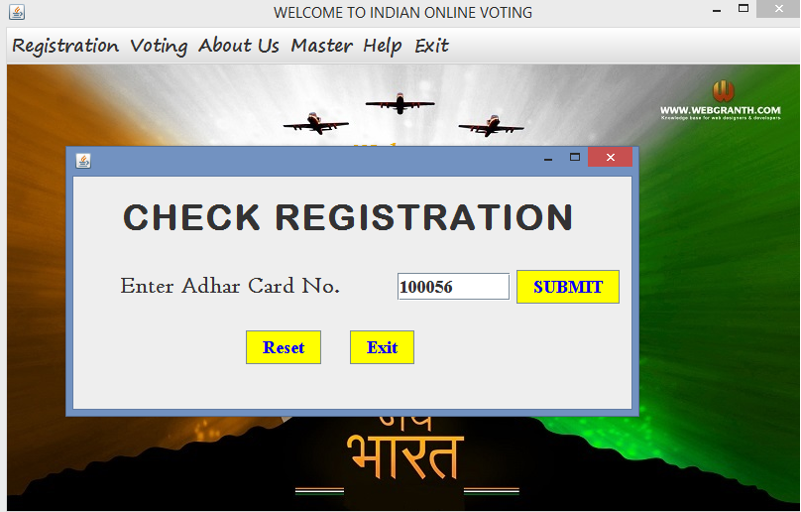

1. Enter your AdharCard no. Click on SUBMIT button.
2. If you are registered than:

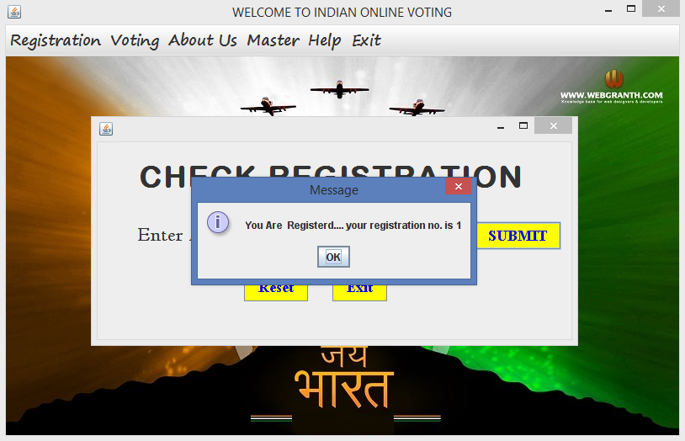

1. If you have adhar card number and not yet registered than:

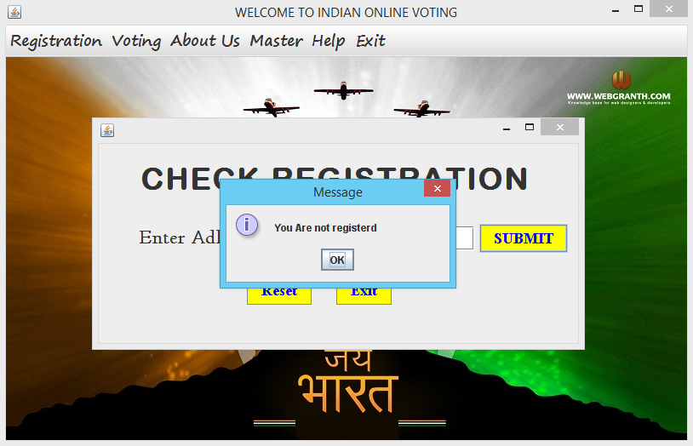

1. If your adhar card number is wrong than:

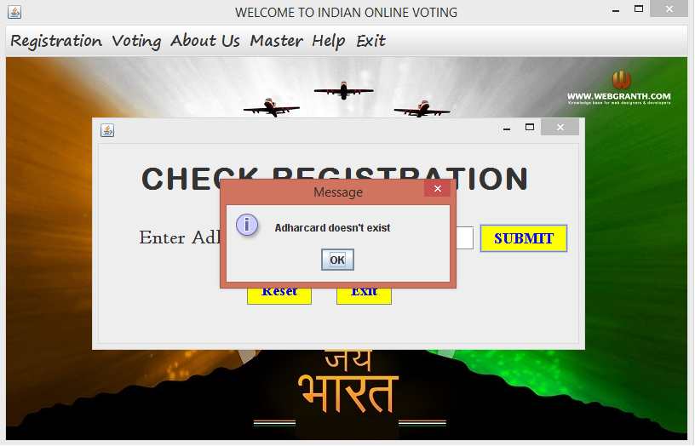

Button SUBMIT:

private void but1ActionPerformed(java.awt.event.ActionEvent evt) {

int b=Integer.parseInt(t1.getText()); //to accept adhar card

{ try

{

Class.forName("java.sql.DriverManager");

Connection C=(Connection)DriverManager.getConnection("jdbc:mysql://localhost:3306/ovs","root","RRMPS");

Statement S=(Statement)C.createStatement();

Statement S1=(Statement)C.createStatement();

String query="select * from registration WHERE ADHARCARDNO='"+b+"';";

String query2="select * from adharcard where adh='"+b+"';";

ResultSet r =S.executeQuery(query);

ResultSet r1 =S1.executeQuery(query2);

if(r1.first()==false) //check the Availability of adhar card no

{ JOptionPane.showMessageDialog(this,"Adharcard doesn't exist"); }

if(r.first()==false&&r1.first()==true) //Check whether you are registered or not

{ JOptionPane.showMessageDialog(this,"You Are not registerd"); }

if(r.first()==true&&r1.first()==true)

{

String ni=r.getString("regno");

JOptionPane.showMessageDialog(this,"You Are Registerd.... your registration no. is "+ ni);

}

}

catch(Exception e)

{

}

}}

Button RESET:

private void but3ActionPerformed(java.awt.event.ActionEvent evt) {

t1.setText("");}

Button EXIT:

private void but2ActionPerformed(java.awt.event.ActionEvent evt) {

System.exit(0);

}

Step 3: If you have any query regarding to your Adhar card no. or Registration no.

1. Move to Help Menu and click on About Registration than Any query.

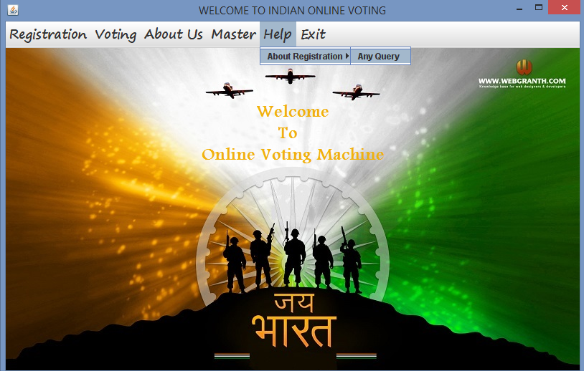

1. Query form will be open.



1. Insert all the details required.

Button SUBMIT:

private void kActionPerformed(java.awt.event.ActionEvent evt) {

String m=ta.getText(); //getting Query

String r=t1.getText(); //getting registration No.

String e=te.getText(); //getting e-mail id

String l=t2.getText(); //getting adhar card no

if (ma.isSelected()==true) //if adhar card radiobutton is Selected

{

if (t1.getText().equals("")) {

JOptionPane.showMessageDialog(this,"Please fill registration no.....");}

else if(te.getText().equals("")) {

JOptionPane.showMessageDialog(this,"Please fill e-mail id.....");}

else if(ta.getText().equals("")) {

JOptionPane.showMessageDialog(this,"Please fill your query.....");}

else{

int n=JOptionPane.showConfirmDialog(this,"Are you sure that you have provided all information completely and correctly "+"\n"+

"NOTE: If any information not provided than adharcard will not be created ");

if(n==0)

{

try{

Class.forName("java.sql.DriverManager");

Connection C=(Connection)DriverManager.getConnection("jdbc:mysql://localhost:3306/OVS","root","RRMPS");

Statement S=(Statement)C.createStatement();

String query="Insert Into Message Values('"+r+"','"+m+"','"+e+"','"+l+"');";

S.executeUpdate(query);

JOptionPane.showMessageDialog(null,"Message Sent!!!!"+ "\n Your reply will be sent to your e-mail id");

}

catch(Exception ec){

JOptionPane.showMessageDialog(this,ec.getMessage());

}

}

//end of catch

//end of try

}

else if (fem.isSelected()==true) //if registration number radiobutton is Selected

{

if (t2.getText().equals("")) {

JOptionPane.showMessageDialog(this,"Please fill adharcard no.....");}

else if(te.getText().equals("")) {

JOptionPane.showMessageDialog(this,"Please fill e-mail id.....");}

else if(ta.getText().equals("")) {

JOptionPane.showMessageDialog(this,"Please fill your query.....");}

else{

try{

Class.forName("java.sql.DriverManager");

Connection C=(Connection)DriverManager.getConnection("jdbc:mysql://localhost:3306/OVS","root","RRMPS");

Statement S=(Statement)C.createStatement();

String query="Insert Into Message Values('"+r+"','"+m+"','"+e+"','"+l+"');";

S.executeUpdate(query);

JOptionPane.showMessageDialog(null,"Message Sent!!!!"+ "\n Your reply will be sent to your e-mail id");

}

catch(Exception ec){

JOptionPane.showMessageDialog(this,ec.getMessage());

} //end of if

}

}

else if (fem1.isSelected()==true) //if others radiobutton is Selected

{

if (te.getText().equals("")) {

JOptionPane.showMessageDialog(this,"Please fill e-mail id.....");}

else if(ta.getText().equals("")) {

JOptionPane.showMessageDialog(this,"Please fill your query.....");}

else{

try{

Class.forName("java.sql.DriverManager");

Connection C=(Connection)DriverManager.getConnection("jdbc:mysql://localhost:3306/OVS","root","RRMPS");

Statement S=(Statement)C.createStatement();

String query="Insert Into Message Values('"+r+"','"+m+"','"+e+"','"+l+"');";

S.executeUpdate(query);

JOptionPane.showMessageDialog(null,"Message Sent!!!!"+ "\n Your reply will be sent to your e-mail id");

}

catch(Exception ec){

JOptionPane.showMessageDialog(this,ec.getMessage());

} //end of if

}

}

}

Button CLEAR:

private void jButton2ActionPerformed(java.awt.event.ActionEvent evt) {

buttonGroup1.clearSelection();

t1.setText(""); //for clearing registration no textfield

te.setText(""); //for clearing email textfield

t2.setText(""); //for clearing adharcard no textfield

ta.setText(""); //for clearing Query textfield

t2.setEnabled(false); //for disabling AdharCard textfield

t1.setEnabled(false); //for disabling registration textfield

te.setEnabled(false); //for disabling email textfield

ta.setEnabled(false); //for disabling Query textfield

}

Button EXIT:

private void jButton9ActionPerformed(java.awt.event.ActionEvent evt) {

System.exit(0);

}

Step 4: Voting System

1. Click On Voting Menu.
2. Click on Cast Vote Menu Item.
3. Login Screen will be activated. Then Submit all the Correct Details.

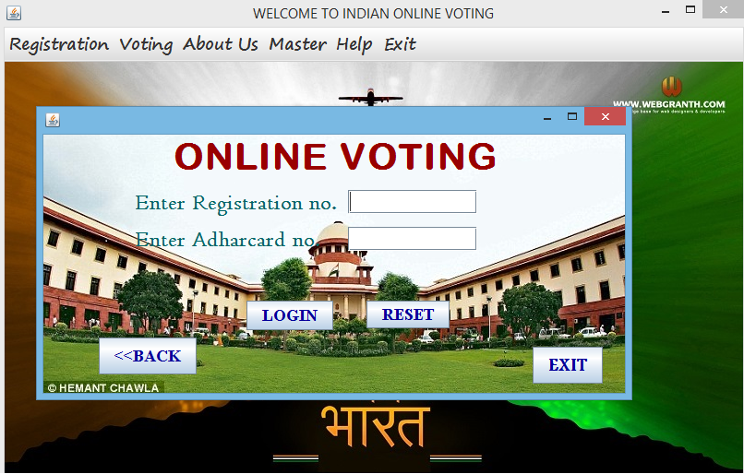

1. If your Details are wrong then Error will occur.

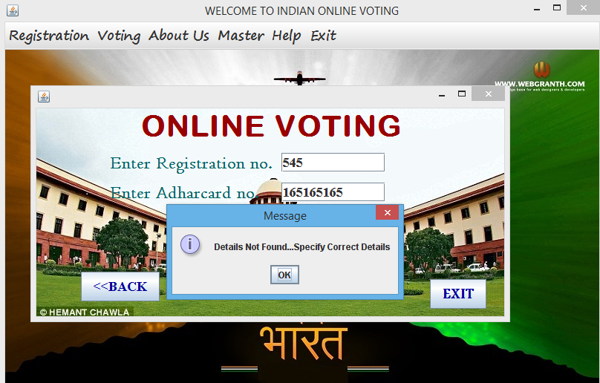

Button Login:

{ try

{

if(t1.getText().equals(""))

{

JOptionPane.showMessageDialog(this,"Please fill Adhar card no","",0);

}

else if(t2.getText().equals(""))

{

JOptionPane.showMessageDialog(this,"Please fill Registration no","",0);

}

else{

long ad,am;

ad=Long.parseLong(t1.getText());

am=Long.parseLong(t2.getText());

Class.forName("java.sql.DriverManager");

Connection C=(Connection)DriverManager.getConnection("jdbc:mysql://localhost:3306/ovs","root","RRMPS");

Statement S=(Statement)C.createStatement();

Statement Sa=(Statement)C.createStatement();

Statement Sb=(Statement)C.createStatement();

{String query="select * from REGISTRATION WHERE ADHarcardno='"+ad+"'and regno='"+am+"' ;";

ResultSet r =S.executeQuery(query);

if(r.first()==false) {

JOptionPane.showMessageDialog(this,"Details Not Found...Specify Correct Details");

}

else {String query2="select * from VOTELIST WHERE ADHarcardno='"+ad+"'and REGISTRATION='"+am+"' ;";

ResultSet rs =S.executeQuery(query2);

if(rs.next()==false){

String query1="Insert Into VOTELIST values('"+ad+"','"+am+"');";

Sa.executeUpdate(query1);

JOptionPane.showMessageDialog(this,"Welcome!!!!!!!!!!");

new EVM().setVisible(true);

}

else

{JOptionPane.showMessageDialog(this,"You Have Already Voted.\n You Cannot give more than one Vote!!","Warning",0);

}

}

}}}

catch(Exception e) {

JOptionPane.showMessageDialog(this, e.getMessage());

}}

Button Reset:

t1.setText("");

t2.setText("");

}

Button Exit:

this.dispose();

1. If your Details are correct then following screen will be activated.

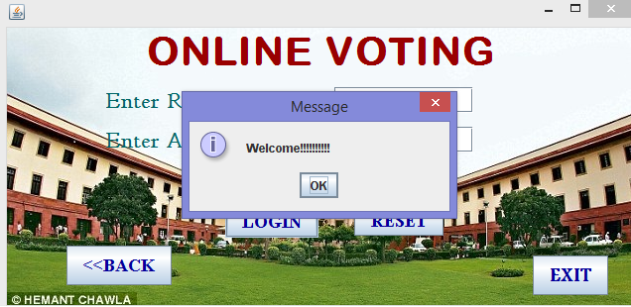

1. As soon as you Click on OK following screen will be activated.

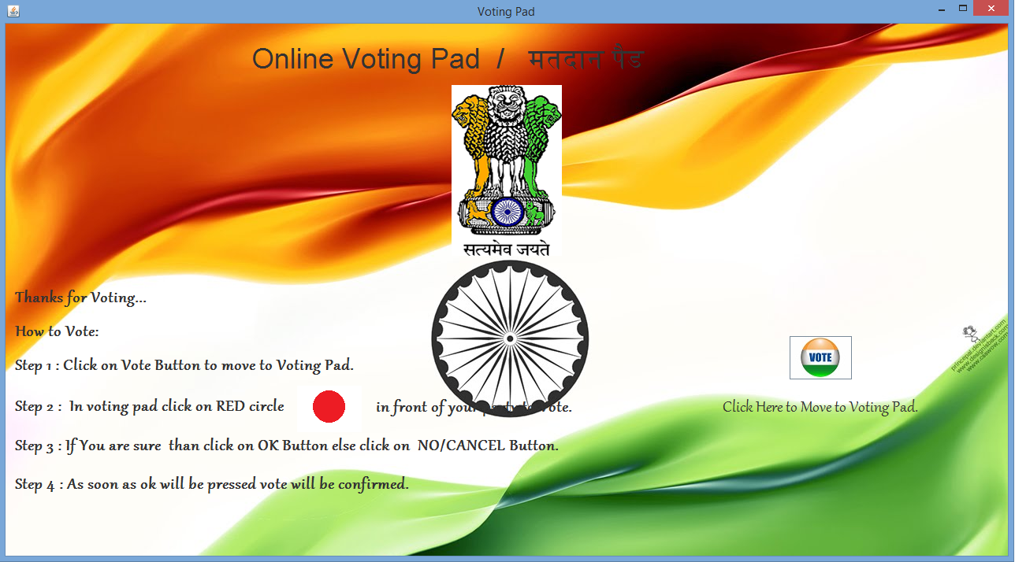

1. Read the Instruction given and click on vote button.
2. Then Voting pad will be open and now you can vote.

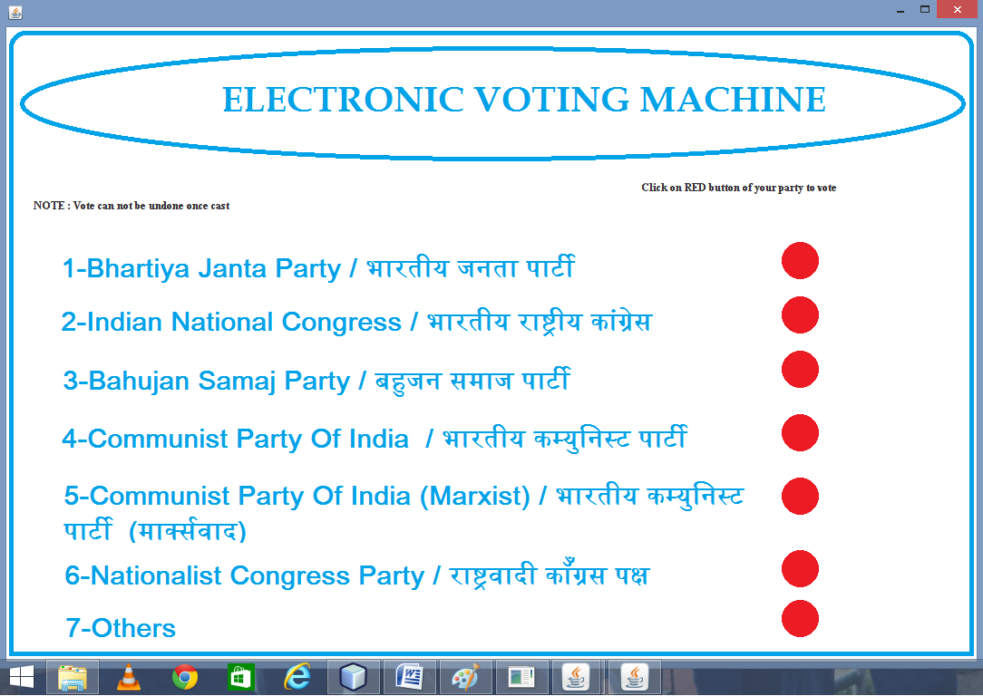

1. To vote click on red button after the given after the party.

Red Button :

String a="BHARTIYA JANTA PARTY";

try

{

int n=JOptionPane.showConfirmDialog(this,"Are you sure to Vote "+a);

if(n==0)

{

Class.forName("java.sql.DriverManager");

Connection C=(Connection)DriverManager.getConnection("jdbc:mysql://localhost:3306/OVS","root","RRMPS");

Statement S=(Statement)C.createStatement();

String query="select * from VOTINGPAD WHERE PARTYNAME='"+a+"';";

ResultSet r =S.executeQuery(query);

r.next();

String b=r.getString("VOTE");

int c=Integer.parseInt(b);

int d=c+1;

Statement Sa=(Statement)C.createStatement();

String query1="update VotingPad set Vote='"+d+"' Where PARTYNAME='"+a+"';";

Sa.executeUpdate(query1);

JOptionPane.showMessageDialog(this,"Thanks! for Voting....Now you can not undo your vote","Thanks",1);

JOptionPane.showMessageDialog(this,"Now please give your precious time for giving feedback of our application ONLINE VOTING MACHINE","REQUEST",1);

{new feedback().setVisible(true);}

this.dispose();

}

}

catch(Exception e)

{

JOptionPane.showMessageDialog(this,"SORRY");

}

//Note For ALL RED BUTTON ARE SAME EXCEPT STRING A=”PARTY NAME”;

1. After clicking on red button a message will come.

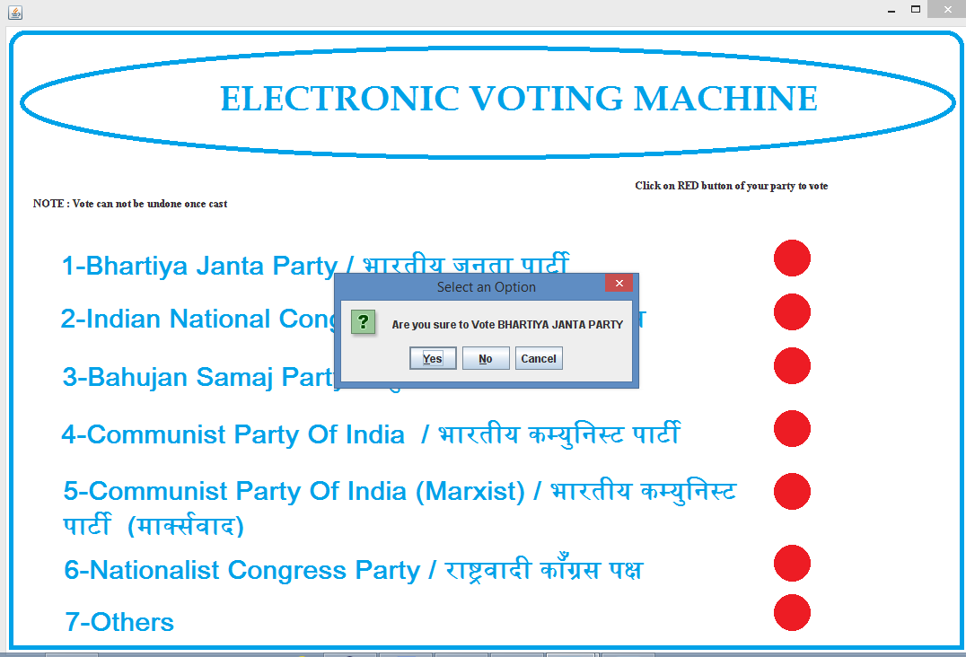

1. As soon as you are sure to vote click Yes. After clicking Yes a new Message will be generated.

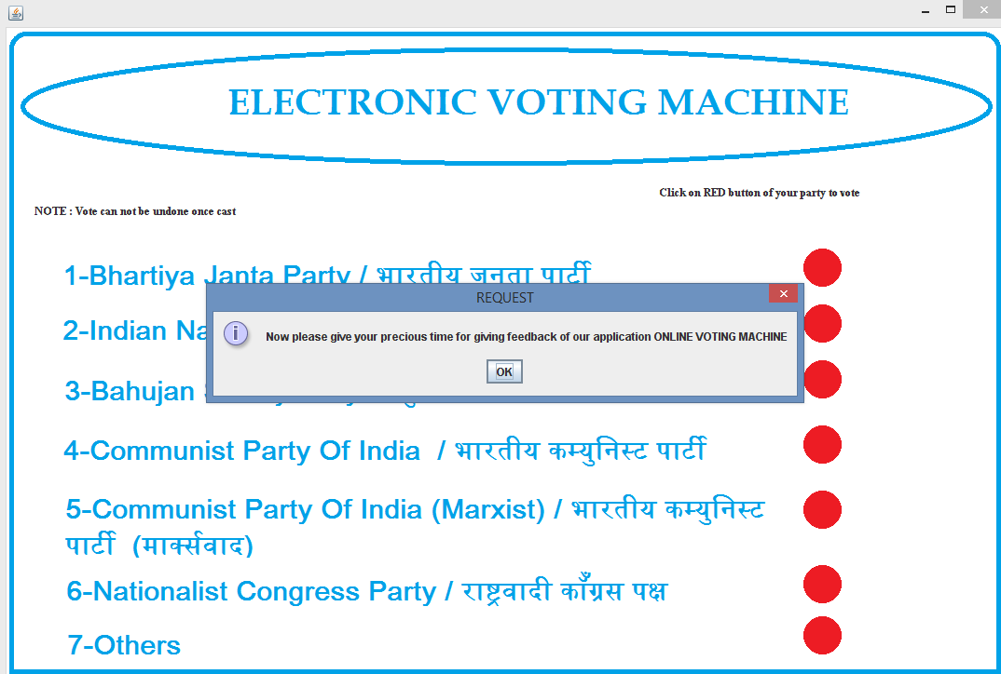

1. It will ask you for a feedback of our application ONLINE VOTING MACHINE. As soon as you click on OK FEEDBACK window will be activated.

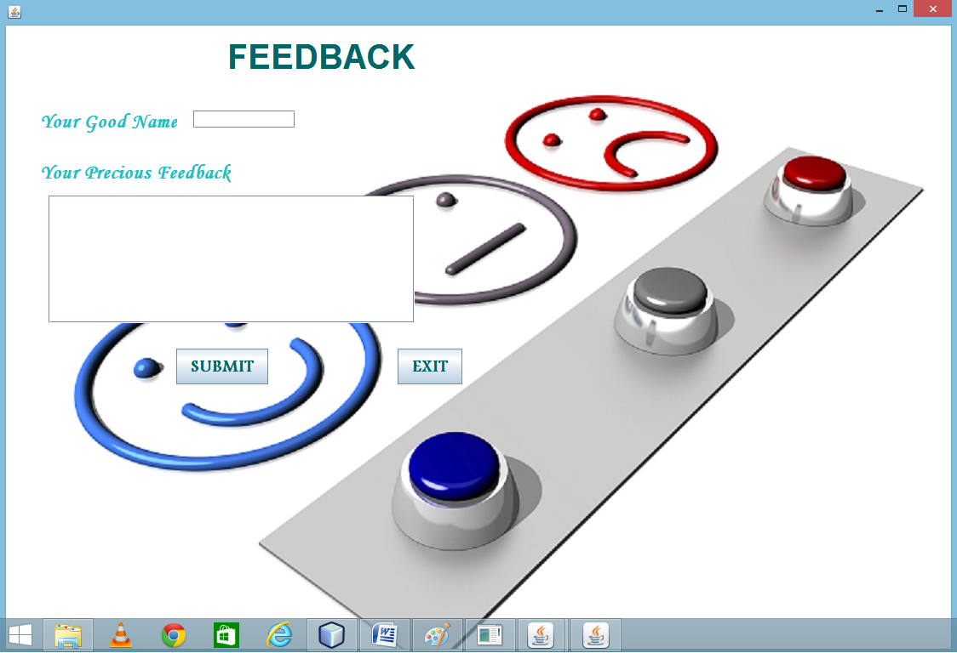

1. Enter your name and your precious feedback and click on Submit.

Button Submit:

private void jButton1ActionPerformed(java.awt.event.ActionEvent evt) {

String Name=t1.getText();

String feed=t2.getText();

int serial;

if (t1.getText().equals(""))

{JOptionPane.showMessageDialog(this,"Please fill your Good Name.....");}

else if (t2.getText().equals(""))

{JOptionPane.showMessageDialog(this,"Please give feedback");}

else { try

{

Class.forName("java.sql.DriverManager");

Connection C=(Connection)DriverManager.getConnection("jdbc:mysql://localhost:3306/OVS","root","RRMPS");

Statement S=(Statement)C.createStatement();

String query="select max(serialno) from feedback;";

ResultSet r =S.executeQuery(query);

r.next();

int acc=Integer.parseInt(r.getString("max(serialno)"));

serial=acc+1;

String A="Insert Into feedback values('"+serial+"','"+Name+"','"+feed+"');";

S.executeUpdate(A);

JOptionPane.showMessageDialog(null,"thanks for your feedback!!!! ");

new homepage().setVisible(true);

}catch(Exception e){JOptionPane.showMessageDialog(this,e.getMessage());}

}

}

Button Exit:

System.exit(0);

1. To check Result Click on Voting Menu item than Click on Results.
2. Result window will be activated.

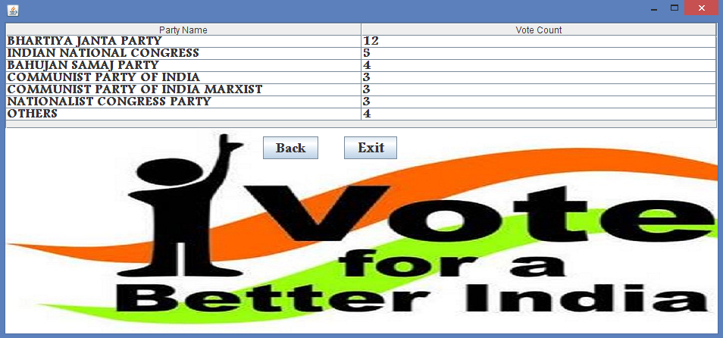

Step 5: If you want to know About Us

1. Click on about us menu item. If you want to know Our Aim of this application than click on Our Aim Menu item.

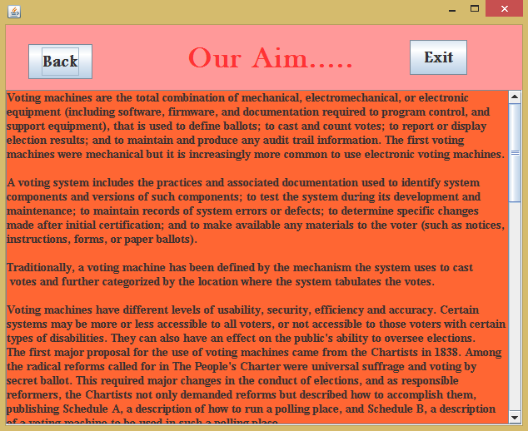

1. If you want to know about developers than click on Developers Menu item.

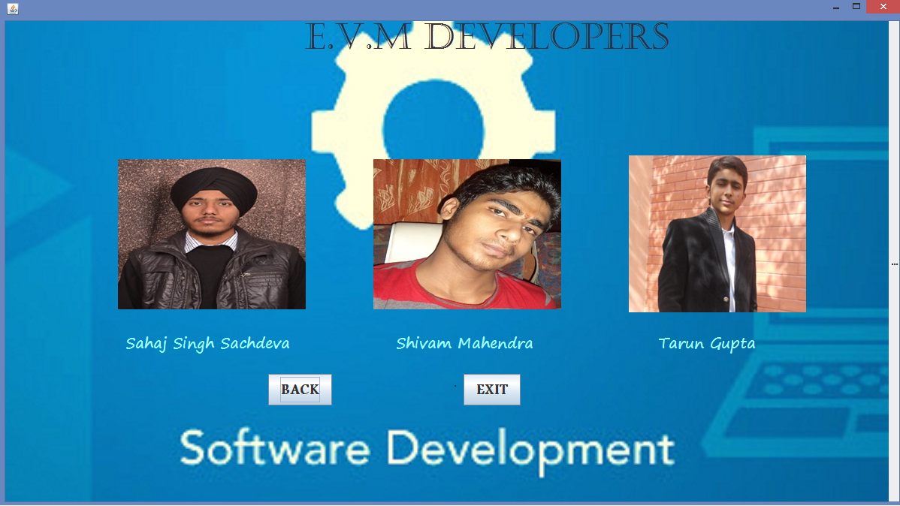

**Now after user it’s time for administration mode………**

Step 5: For Administrator Login

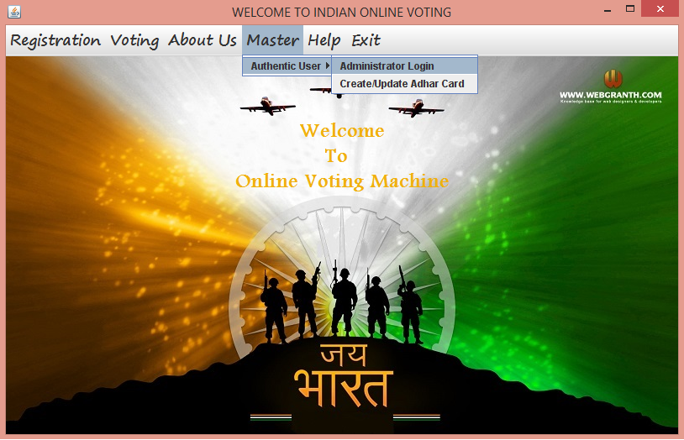

1. Click on Master Menu. Then click on Authentic User MenuItem. Click On Administrator Login.
2. Password will be enquired.

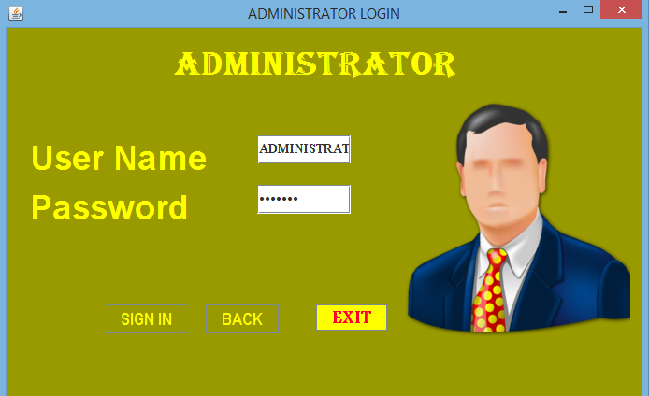

1. Enter username and Password.
2. Click on SIGN IN.
3. If password is incorrect than:

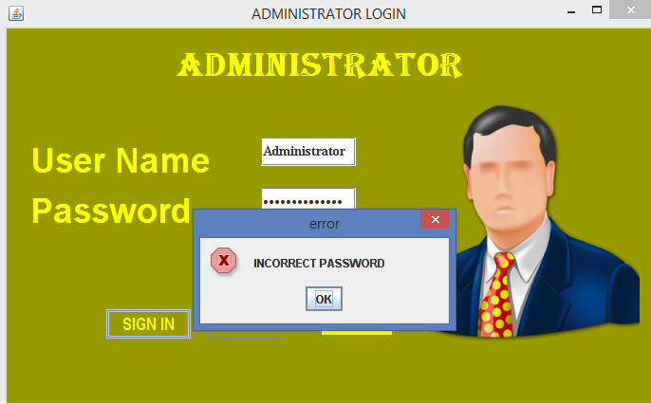

1. If password is correct than Administer page will be log on.

Button SIGN IN:

private void jButton1ActionPerformed(java.awt.event.ActionEvent evt) {

String us=(String)t1.getText(); //getting username

String ps=t2.getText(); //getting password

{ try {

Class.forName("java.sql.DriverManager");

Connection C=(Connection)DriverManager.getConnection("jdbc:mysql://localhost:3306/ovs","root","RRMPS");

Statement S=(Statement)C.createStatement();

String query="select * from ADMINISTRATOR where administrator='"+us+"';";

ResultSet r =S.executeQuery(query);

r.next();

String pwd=r.getString("password"); //getting password from database

String user=r.getString("ADMINISTRATOR"); //getting username from database

{

{

if (us.equalsIgnoreCase(user)) //matching application username with database username

{

if(ps.equals(pwd)) //matching application password with database password

{

this.setVisible(false);

new administration().setVisible(true);

}

else

{

JOptionPane.showMessageDialog(null,"INCORRECT PASSWORD" ,"error",0);

}

}

}}}

catch(Exception e)

{

JOptionPane.showMessageDialog(null,"INCORRECT USERNAME or PASSWORD or is CASE SENSITIVE","error",0);

}}

}

Button BACK:

private void jButton2ActionPerformed(java.awt.event.ActionEvent evt) {

this.setVisible(false);

new homepage().setVisible(true);

}

Button EXIT:

private void formWindowClosing(java.awt.event.WindowEvent evt) {

int i=JOptionPane.showConfirmDialog(this,"Do you Want To Exit");

if(i==0)

{System.exit(0);}

Administrator Window:

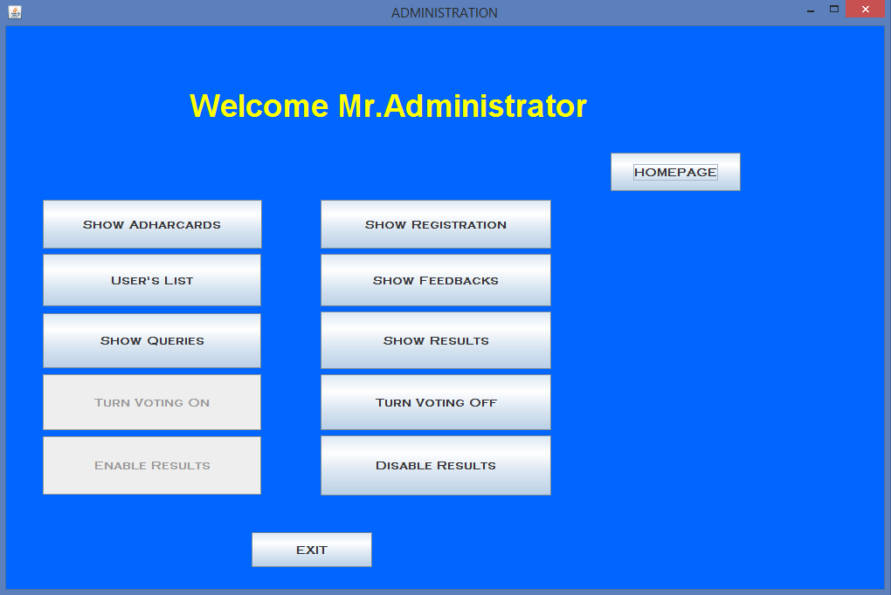

SHOW ADHARCARDS:

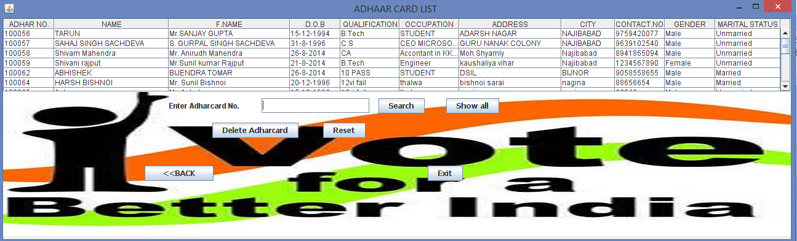

Source Code of this window:

private void formWindowOpened(java.awt.event.WindowEvent evt) {

DefaultTableModel model=(DefaultTableModel)d1.getModel();

try

{

Class.forName("java.sql.DriverManager");

Connection c=(Connection)DriverManager.getConnection

("jdbc:mysql://localhost:3306/ovs","root","RRMPS");

Statement S=(Statement)c.createStatement();

String query="select * from ADHARCARD;";

ResultSet rs=S.executeQuery(query);

while(rs.next())

{

String sn=rs.getString("ADH");

String un=rs.getString("NAME");

String cn=rs.getString("FNAME");

String pass=rs.getString("DOB");

String pn=rs.getString("QU");

String jn=rs.getString("O");

String cs=rs.getString("A");

String rn=rs.getString("C");

String cno=rs.getString("CNO");

String ge=rs.getString("G");

String ms=rs.getString("S");

model.addRow(new Object[]

{sn,un,cn,pass,pn,jn,cs,rn,cno,ge,ms});

}

}

catch(Exception e)

{

JOptionPane.showMessageDialog(null,e.getMessage());

}

Button Search:

private void jButton2ActionPerformed(java.awt.event.ActionEvent evt) {

int b=Integer.parseInt(se.getText());

DefaultTableModel model=(DefaultTableModel)d1.getModel();

{ {

}

try

{

Class.forName("java.sql.DriverManager");

Connection c=(Connection)DriverManager.getConnection

("jdbc:mysql://localhost:3306/ovs","root","RRMPS");

Statement S=(Statement)c.createStatement();

String query="select * from ADHARCARD where ADH='"+b+"';";

ResultSet rs=S.executeQuery(query);

{

int i=model.getRowCount();

while (i>0)

{

model.removeRow(0);

i--;

while(rs.next())

{

String sn=rs.getString("ADH");

String un=rs.getString("NAME");

String cn=rs.getString("FNAME");

String pass=rs.getString("DOB");

String pn=rs.getString("QU");

String jn=rs.getString("O");

String cs=rs.getString("A");

String rn=rs.getString("C");

String cno=rs.getString("CNO");

String ge=rs.getString("G");

String ms=rs.getString("S");

model.addRow(new Object[]

{sn,un,cn,pass,pn,jn,cs,rn,cno,ge,ms});

}

}

}}

catch(Exception e)

{

JOptionPane.showMessageDialog(null,e.getMessage());

}

Button Show All:

private void jButton4ActionPerformed(java.awt.event.ActionEvent evt) {

se.setText("");

DefaultTableModel model=(DefaultTableModel)d1.getModel();

{

int i=model.getRowCount();

while (i>0)

{

model.removeRow(0);

i--;

}

}

try

{

Class.forName("java.sql.DriverManager");

Connection c=(Connection)DriverManager.getConnection

("jdbc:mysql://localhost:3306/ovs","root","RRMPS");

Statement S=(Statement)c.createStatement();

String query="select * from ADHARCARD;";

ResultSet rs=S.executeQuery(query);

while(rs.next())

{

String sn=rs.getString("ADH");

String un=rs.getString("NAME");

String cn=rs.getString("FNAME");

String pass=rs.getString("DOB");

String pn=rs.getString("QU");

String jn=rs.getString("O");

String cs=rs.getString("A");

String rn=rs.getString("C");

String cno=rs.getString("CNO");

String ge=rs.getString("G");

String ms=rs.getString("S");

model.addRow(new Object[]

{sn,un,cn,pass,pn,jn,cs,rn,cno,ge,ms});

}

}

catch(Exception e)

{

JOptionPane.showMessageDialog(null,e.getMessage());

}

Button Delete Adhar Card:

private void jButton3ActionPerformed(java.awt.event.ActionEvent evt) {

int mid=d1.getSelectedRow();

String k=(""+d1.getValueAt(mid,0));

int a[]=d1.getSelectedRows();

DefaultTableModel dm=(DefaultTableModel)d1.getModel();

int n=JOptionPane.showConfirmDialog(this,"Are you sure to delete this ADHARCARD permanently");

if(n==0)

{

try{

Class.forName("java.sql.DriverManager");

Connection c=(Connection)DriverManager.getConnection("jdbc:mysql://localhost:3306/ovs","root","RRMPS");

Statement s=(Statement)c.createStatement();

Statement S1=(Statement)c.createStatement();

String q="delete from ADHARCARD where ADH =" + k +" ;";

String query2="delete from REGISTRATION where ADHARCARDNO =" + k +" ;";

s.executeUpdate(q);

S1.executeUpdate(query2);

JOptionPane.showMessageDialog(this,"ADHARCARD Deleted!!!","Delete",1);

dm.removeRow(a[0]);

} catch(Exception e) {

JOptionPane.showMessageDialog(this,"ADHARCARD Not Selected","Error",0);

}}

Button Delete Reset:

private void jButton5ActionPerformed(java.awt.event.ActionEvent evt) {

se.setText("");

Button Exit:

private void jButton5ActionPerformed(java.awt.event.ActionEvent evt) {

se.setText("");

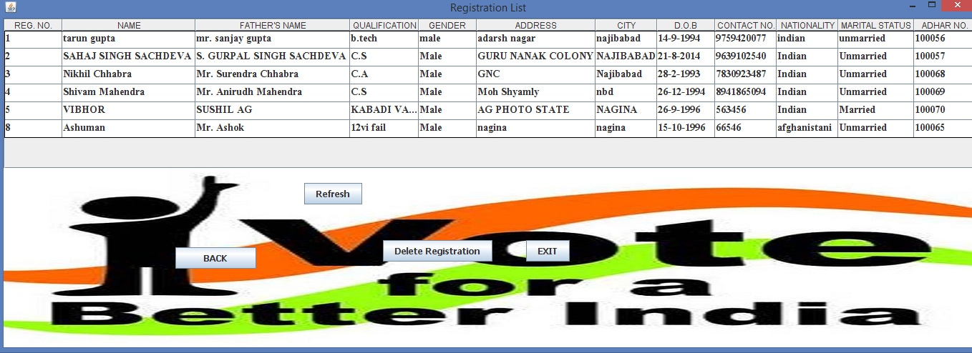

Button Refresh:

new registrationlist().setVisible(true);

Button Delete:

this.setVisible(false);

new deleteregistration().setVisible(true);

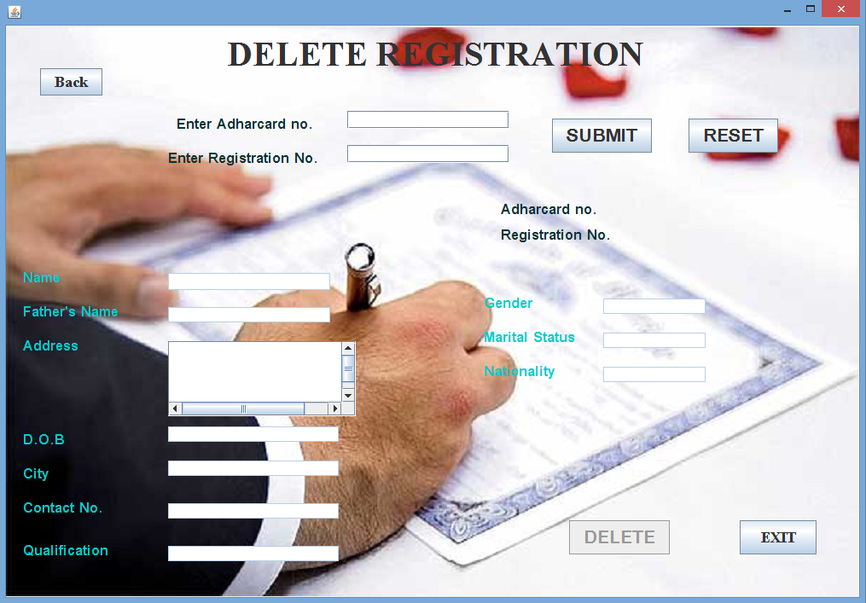

Delete Window will be activated and specify adharcard no and registration no,

Button Submit:

private void but1ActionPerformed(java.awt.event.ActionEvent evt) {

String ad,na;

ad=t1.getText();

na=t2.getText();

try

{

Class.forName("java.sql.DriverManager");

Connection C=(Connection)DriverManager.getConnection("jdbc:mysql://localhost:3306/ovs","root","RRMPS");

Statement S=(Statement)C.createStatement();

String query="select * from REGISTRATION WHERE REGNO='"+ad+"' and ADHARCARDNO ='"+na+"';";

ResultSet r =S.executeQuery(query);

if(!r.first())

{

JOptionPane.showMessageDialog(this,"Details Not Found...Specify Correct Details");

}

else

{ String ni=r.getString("name");

String mi=r.getString("fname");

String o=r.getString("qu");

String p=r.getString("ad");

String w=r.getString("ci");

String x=r.getString("cno");

String y=r.getString("na");

String z=r.getString("ge");

String m=r.getString("ms");

String e=r.getString("dob");

String ei=r.getString("regno");

String ej=r.getString("adharcardno");

n.setText(ni);

f.setText(mi);

qa.setText(o);

a.setText(z);

this.ad.setText(p);

ci.setText(w);

dob.setText(e);

co.setText(x);

nam.setText(y);

ma.setText(m);

l1.setText(ej);

l2.setText(ei);

t1.setEditable(false);

t2.setEditable(false);

but.setEnabled(true);

}

}

catch(Exception e)

{}

Button Delete:

int k =Integer.parseInt(l2.getText());

try{

Class.forName("java.sql.DriverManager");

Connection c=(Connection)DriverManager.getConnection("jdbc:mysql://localhost:3306/ovs","root","RRMPS");

Statement s=(Statement)c.createStatement();

String q="delete from registration where regno =" + k +";";

s.executeUpdate(q);

JOptionPane.showMessageDialog(this,"Registration deleted","deleted",1);

n.setText("");

f.setText("");

ad.setText("");

dob.setText("");

ci.setText("");

co.setText("");

qa.setText("");

a.setText("");

ma.setText("");

nam.setText("");

t2.setText("");

t1.setText("");

t1.setEnabled(true);

t2.setEnabled(true);

but.setEnabled(false);

} catch(Exception e) {

JOptionPane.showMessageDialog(this,"Registration Not deleted","Error",0);

}

Button Reset:

but.setEnabled(false);

l1.setText("");

l2.setText("");

n.setText("");

f.setText("");

ad.setText("");

dob.setText("");

ci.setText("");

co.setText("");

qa.setText("");

a.setText("");

ma.setText("");

nam.setText("");

t1.setText("");

t2.setText("");

t1.setEditable(true);

t2.setEditable(true);

In admin page

Button User’s list:

new USERLIST().setVisible(true);

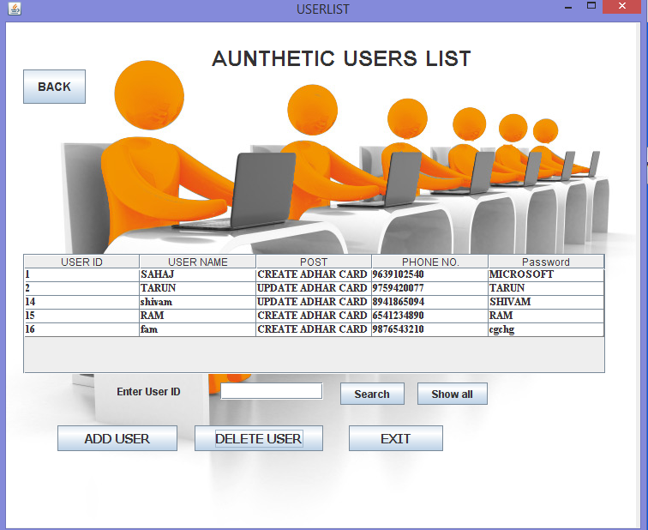

Button Search:

int b=Integer.parseInt(se.getText());

DefaultTableModel model=(DefaultTableModel)d1.getModel();

{ {

}

try

{

Class.forName("java.sql.DriverManager");

Connection c=(Connection)DriverManager.getConnection

("jdbc:mysql://localhost:3306/ovs","root","RRMPS");

Statement S=(Statement)c.createStatement();

String query="select * from USERTABLE where SERIAL='"+b+"';";

ResultSet rs=S.executeQuery(query);{

int i=model.getRowCount();

while (i>0)

{

model.removeRow(0);

i--;

while(rs.next())

{

String sn=rs.getString("SERIAL");

String un=rs.getString("USERN");

String cn=rs.getString("POST");

String pass=rs.getString("CONTACTS");

String pn=rs.getString("PASSWORD");

model.addRow(new Object[]

{sn,un,cn,pass,pn});

}}}}

catch(Exception e)

{JOptionPane.showMessageDialog(null,e.getMessage());}

Button Show All:

private void jButton5ActionPerformed(java.awt.event.ActionEvent evt) {

se.setText("");

DefaultTableModel model=(DefaultTableModel)d1.getModel();

{

int i=model.getRowCount();

while (i>0)

{

model.removeRow(0);

i--;

}

}

try

{

Class.forName("java.sql.DriverManager");

Connection c=(Connection)DriverManager.getConnection

("jdbc:mysql://localhost:3306/ovs","root","RRMPS");

Statement S=(Statement)c.createStatement();

String query="select * from USERTABLE;";

ResultSet rs=S.executeQuery(query);

while(rs.next())

{

String sn=rs.getString("SERIAL");

String un=rs.getString("USERN");

String cn=rs.getString("POST");

String pass=rs.getString("CONTACTS");

String pn=rs.getString("PASSWORD");

model.addRow(new Object[]

{sn,un,cn,pass,pn,});

}

}

catch(Exception e)

{

JOptionPane.showMessageDialog(null,e.getMessage());

}

Button Add User:

new adduser().setVisible(true);

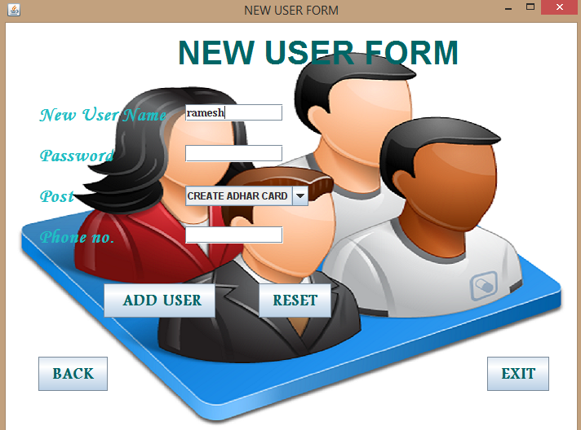

Button Add User: (of this activated window)

private void jButton1ActionPerformed(java.awt.event.ActionEvent evt) {

String Name=t1.getText();

Object post=t2.getSelectedItem();

String password=t3.getText();

String cno=t4.getText();//

int lcn=cno.length();

int serial;

if (t1.getText().equals(""))

{JOptionPane.showMessageDialog(this,"Please fill Name.....");}

else if (t3.getText().equals(""))

{JOptionPane.showMessageDialog(this,"Please fill Password......");}

else if (t4.getText().equals(""))

{JOptionPane.showMessageDialog(this,"Please fill Phone No......");}

else if (lcn>10 || lcn<=9)//checking whether mobile field should not have less than or more than 10 values

{

JOptionPane.showMessageDialog(this,"Please fill valid Contact no.....");

}

else { try

{

Class.forName("java.sql.DriverManager");

Connection C=(Connection)DriverManager.getConnection("jdbc:mysql://localhost:3306/OVS","root","RRMPS");

Statement S=(Statement)C.createStatement();

String query="select max(serial) from usertable;";

ResultSet r =S.executeQuery(query);

r.next();

int acc=Integer.parseInt(r.getString("max(serial)"));

serial=acc+1;

String A="Insert Into usertable values('"+serial+"','"+Name+"','"+post+"','"+cno+"','"+password+"');";

S.executeUpdate(A);

JOptionPane.showMessageDialog(null,"Registration Successfull!!!!"+ "\n User ID is "+serial);

}catch(Exception e){JOptionPane.showMessageDialog(this,e.getMessage());}

}

Button Reset:

t1.setText("");

t3.setText("");

t4.setText("");

t2.setSelectedIndex(0);

Button Reset:

int mid=d1.getSelectedRow();

String k=(""+d1.getValueAt(mid,0));

int a[]=d1.getSelectedRows();

DefaultTableModel dm=(DefaultTableModel)d1.getModel();

int n=JOptionPane.showConfirmDialog(this,"Are you sure to Delete this USER permanently ");

if(n==0)

{

try{

Class.forName("java.sql.DriverManager");

Connection c=(Connection)DriverManager.getConnection("jdbc:mysql://localhost:3306/ovs","root","RRMPS");

Statement s=(Statement)c.createStatement();

String q="delete from USERTABLE where SERIAL =" + k +" ;";

s.executeUpdate(q);

JOptionPane.showMessageDialog(this,"User's Account Deleted!!!","Delete",1);

dm.removeRow(a[0]);

se.setText( "");

} catch(Exception e) {

JOptionPane.showMessageDialog(this,"User Account Not Selected","Error",0);

}}

In admin page

Button Show feedback:

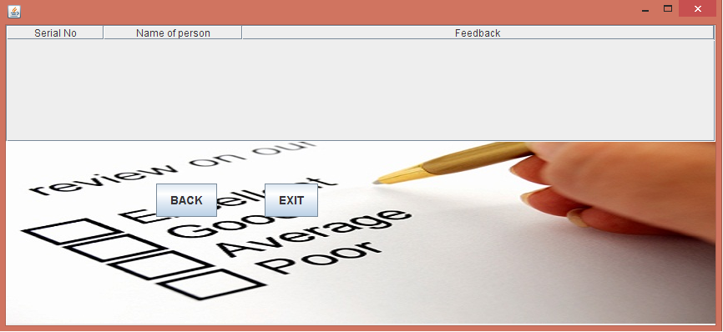

Button Show Quries:

new Show_Query().setVisible(true);

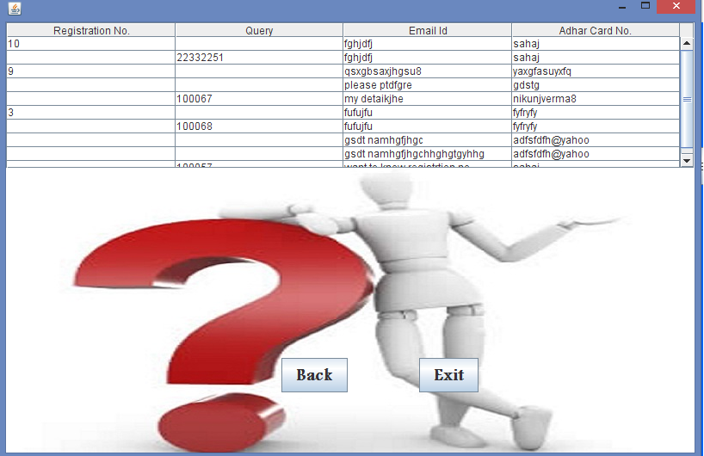

Button Show Exit:

this.dispose();

In admin window

Button Show Results:

new Result().setVisible(true);

Button Show Turn Voting ON:

try

{Class.forName("java.sql.DriverManager");

Connection C=(Connection)DriverManager.getConnection("jdbc:mysql://localhost:3306/OVS","root","RRMPS");

Statement S=(Statement)C.createStatement();

String query="Update status set status=1 where status=0;";

S.executeUpdate(query);

BUT2.setEnabled(false);

BUT1.setEnabled(true);

}

catch(Exception e){

JOptionPane.showMessageDialog(this,e.getMessage());

}

Button Show Turn Voting ON:

try

{Class.forName("java.sql.DriverManager");

Connection C=(Connection)DriverManager.getConnection("jdbc:mysql://localhost:3306/OVS","root","RRMPS");

Statement S=(Statement)C.createStatement();

String query="Update status set status=0 where status=1;";

S.executeUpdate(query);

BUT1.setEnabled(false);

BUT2.setEnabled(true);

}

catch(Exception e){

JOptionPane.showMessageDialog(this,e.getMessage());

}

Button Enable Results:

private void BUT4ActionPerformed(java.awt.event.ActionEvent evt) {

try

{Class.forName("java.sql.DriverManager");

Connection C=(Connection)DriverManager.getConnection("jdbc:mysql://localhost:3306/OVS","root","RRMPS");

Statement S=(Statement)C.createStatement();

String query="Update resultstatus set status=1 where status=0;";

S.executeUpdate(query);

BUT4.setEnabled(false);

BUT3.setEnabled(true);

}

catch(Exception e){

JOptionPane.showMessageDialog(this,e.getMessage());}

Button Disable Results:

try

{Class.forName("java.sql.DriverManager");

Connection C=(Connection)DriverManager.getConnection("jdbc:mysql://localhost:3306/OVS","root","RRMPS");

Statement S=(Statement)C.createStatement();

String query="Update resultstatus set status=0 where status=1;";

S.executeUpdate(query);

BUT3.setEnabled(false);

BUT4.setEnabled(true);

}

catch(Exception e){

JOptionPane.showMessageDialog(this,e.getMessage());

}

Button Exit:

System.exit(0);

Button Homepage:

new homepage().setVisible(true);

Special Objects we have used:

* Date Chooser Combo
* JTable

Special Objects we have used:

* In all forms Window closing property will be set to

int i=JOptionPane.showConfirmDialog(this,"Do you Want To Exit");

if(i==0)

{this.dispose();}

* In all windows containing input area, then window activated property will be set to

n.requestFocus(true);

* All the forms Default Close Property will be changed to User Code
* The user code is

Form.setDefaultCloseOperation(0);

**Remarks:**

**Thank**

**You!!!**